**SETS**

Equivalent sets

A set is a collection of well-defined elements

**Review**

Equal sets

Intersection sets

Union sets

Difference of sets

**SUBSETS**

A subset is a set that can be obtained /formed from any given set.

A symbol for subset is ⊆ (is a subset of)

**Venn diagrams about subsets**

**Examples**

Draw a Venn diagram to show that all hens(H) are birds (B)

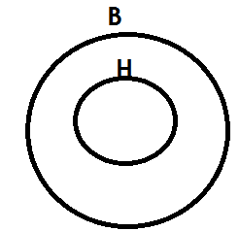 Solution

Draw a Venn diagram to show that set A=A n B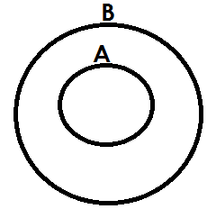

With the help of a venin diagram show that n (P) =n (P u Q)

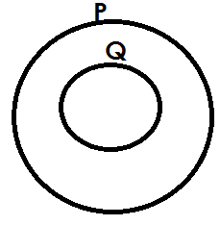 Solution

**Activity**

1. Draw a Venn diagram to show that all cows(C) are animals(A)

2. With the help of a Venn diagram show that all girls (G) are female (F).

3. Draw a Venn diagram to show that set K=P n K

4. With the help of a Venn diagram, show that n (P) =n (X u P)

5. If n (A) =n(An), show the illustration using a Venn diagram.

**Listing subsets**

**Note:**

An empty set is a subset of every set.

Any given set is a subset of itself.

Equal sets are not subsets of a given set. e.g. {a, b} and {b, a} since they are taken to be the same.

**Example1**

Set A= {2}. List all subsets in set A

**Solution**

{ }, {2}

**Example 2**

If set T= {a, b}, list all subsets in set T.

**Solution**

{ }, {a}, {b}, {a, b}

**Example3**

Given that set M= {m, a, n}. List all subsets in set M.

{ }, {m},{a},{n}, {m, a}, {m, n}, {a, n}, {m, a, n}

**Activity**

1. List all subsets in set A if A=

2. Given that set T= {4} list all subsets in set T

3. If set y= {1, 2}. List all subsets in set y

4. Given that set P= . List all subsets of set P

5. If set A= {c, o, w}. List all subsets in set A.

6. Set P= {Annette, James, Ben}. List all subsets in set P.

7. Set T= {a, b, c, d}. List all subsets in set T

8. Given that set M= {7, 8, 9, 3}. List all subsets that can be formed from set M.

**FINDING NUMBER OF SUBSETS**

**Number of subsets = 2n**

Where: - **n** is number of elements is a given set

2 indicates that, number of subsets are in powers of 2.

**Example1**

Given that set P= { }, find number of subsets in set P.

**Solution**

No. of subsets = 2n

= 20

= 1 subset.

**Example2**

If set T= {5}. Find number of subsets in set T

**Solution**

No. of subsets = 2n

= 21

= 2 subsets

**Example 3**

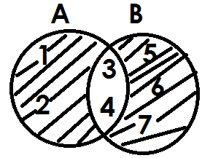Below is set A and B

Find number of subsets in set (A n B) **I**

No. of subsets = 2n

= 25

= 2x2x2x2x2

= 32 subsets

**Examples 4**

If set m= {1, 2, 3, 4, 5, 6, 7, 8} and set

P= {all factors of 12}. Find number of subsets in M n P

M= {1, 2, 3, 4, 5, 6, 7, 8}

P= {1, 2, 3, 4, 6, 12}

M n p= {1, 2, 3, 4, 6}

No. of subsets = 2n

= 25

= 2x2x2x2x2

= 32

**ACTIVITY**

1. Find number of subsets in set P with 4 elements.

2. Given that set y= {all vowel letters}. Find number of subsets in set y.

3. If set K= {a, b, c, d, e, f}, find number of subsets in set K.

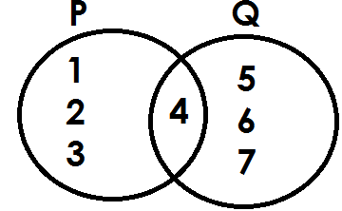4. Below is set P and Q

Find number of subsets in P U Q

6. If set A= {All even numbers less than 10} and set B= {all factors of 12}. Find number of subsets in A n B.

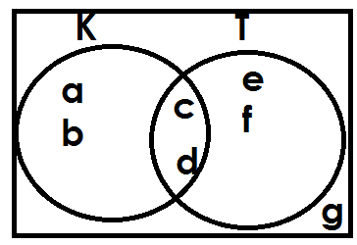7. **Use the Venn diagram below to answer question**

Find number of subsets in K**I**

**FINDING NUMBER OF ELEMENTS GIVEN NUMBER OF SUBSETS**

**Formula:**

2n = No. of subsets

**Examples**

1. Set K has 1 subset. How many elements are in set K?

**Solution**

2n = no of subsets

2n = 1 but 1 = 2**0**

2n = 20

n = 0

No element

2. Set M has 64 subsets. How many elements are in set M?

**Solution**

2n = No. of subsets

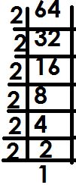 2n = 64

2n =

2n = 2x2x2x2x2x2

2n = 26

n = 6

**Example 3**

3. Set K has 128 subsets. How many elements are in set K?

**Solution**

2n = No. of subsets

2n = 128

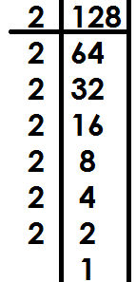 2n =

2n = 27

n = 7

**Example 4**

Set M has 256 subsets. How many elements are in set M?

2n = No. of subsets

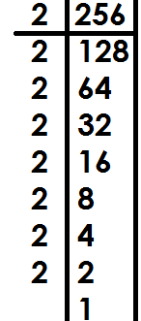 2n = 356

2n =

2n = 28

n = 8

**ACTIVITY.**

1. Set A has 8 subsets. Find the number of elements in set A.

2. There are 4 subsets in a set. How many elements are in that set.

3. Find the number of members in a set with the following number of subsets.

(a) 32 subsets

(b) 64 subsets

(c) 16 subsets

**FINDING PROPER SUBSETS**

(a) **By listing.**

1. If P= {a, b, c}, how many proper subsets has set P?

**Solution**

P= {a, b, c}

{ }, {a}, {b}, {c}, {a, b}, {a, c}, {b, c}

7 proper subsets.

2. Given that M= {p, q, r, s,}. List the number of proper subsets in set M.

**Solution**

M= {p, q, r, s}

{ }, {p}, {q}, {r}, {s}, {p,q},{p, r}, {p,s} {q,r},{q,s}, {r,s},{p,q,r},{p,q,s}, {p,r,s},

{q,r,s}

15 proper subsets

**ACTIVITY**

List the proper subsets for each of the following sets

1. B= {a,b}

2. C= {x, y, z}

3. D= {t}

4. p= {a, b, c, d}

5. q= { }

6. Z= {1, 2, 3}

(b) **By using the formula.**

**Formula:**

No. of proper subsets = 2n – 1

Where n is number of elements in a given set and 1 is the mother being

subtracted from the formula.

**Examples**

1. If x= {1, 2, 3}. Find the number of proper subsets in set X.

**Solution**

Set X has 3 elements, how many proper subsets are in set X?

Proper subsets = 2n-1

= 23-1

= {2x2x2}-1

= 8-1

= 7 proper subsets.

2. Set M = {1}, how many proper subsets are in set M?

Set M has 1 element

No. of proper subsets = 2n-1

= 21-1

= 2-1

= 1 proper subset.

3. How many proper subsets are in a set with 5 elements?

**Solution**

No. of proper subsets = 2n - 1

= 25 - 1

= {2x2x2x2x2} -1

= 32 - 1

= 31 proper subsets.

**Activity**

1. If B= {1, 2}, how many proper subsets are in set B?

2. Given that R= {a, b, c, d, e, f}. Find the number of proper subsets in set R.

3. Find the number of proper subsets of a set which has;

(a) 4 elements

(b) 3 elements

(c) 7 elements

(d) 9 elements

**FINDING NUMBER OF ELEMENTS GIVEN NUMBER OF PROPER SUBSETS**

**Formula;**

2n - 1 = No. of proper subsets

**Examples**

1. Set M has 15 proper subsets. How many elements are in set M?

**Solution**

2n – 1 = No of proper subsets

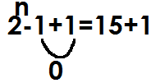 2n - 1 = 15

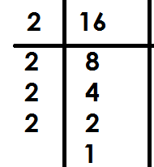 2n = 16

2n =

2n = 24

n =4

2. Set K has 255 proper subsets. How many elements are in set k?

**Solution**

2n-1=no of proper subsets

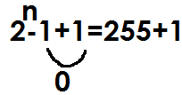 2n - 1 = 255

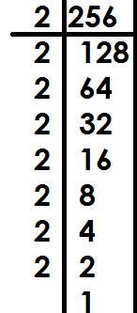 2n = 256

2n =

2n = 2x2x2x2x2x2x2x2

2n = 28

n = 8

3. Set R has 63 proper subsets. Find the number of elements in set R

2n - 1 = No of proper subsets

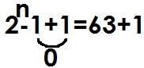2n- 1 = 63

2n = 64

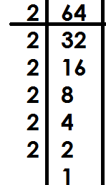2n =

2n = 26

n = 6

**Activity**

1. Set H has 3 proper subsets. How many elements are in set H?

2. There are 15 proper subsets in set D. How many elements are in set D?

3. Find the number of members in a set with;

(a) 31 proper subsets

(b) 7 proper subsets

(c) 511 proper subsets

(d) 1023 proper subsets

**COMPLEMENT OF SETS**

It is a set of elements outside the mentioned set.

**Example**: Complement of P means members in set P are not wanted.

**Example2**

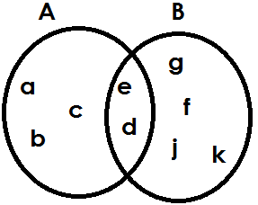Given set A= {a, b, c, d, e} and B= {e, d, g, f, j, k}

a) Find A I = {g, f, j, k}

b) List members of (A n B) I = {a, b, c, g, f, j, k}

c) The complement of B = {a, b, c}

d) List the members of (A-B) I

**Solution**

(A-B) I = {e, d, g, f, j, k}

**Study the Venn diagram below and answer questions**

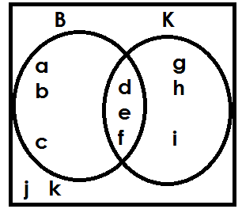

a) Find the complement of set B

B **I** = {g, h, I, j, k}

b) Find

(i) (B n K) **I**

**Solution**

(B n K) **I** = {a, b, c, g, h, I, j, k}(ii) (B u K) **I**

**Solution**

(B u K) **I** = {J, K}

(iii) (K-B) **I**

**Solution**

(K-B) **I** = {a, b, c, d, e, f, j, k}

c) Find the number of elements in set K complement

**Solution**

n(K) **I**

K **I** = {a, b, c, j, k}

n(K) **I** = 5

**Activity**

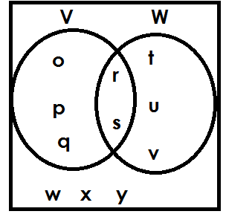 **Study the Venn diagram and answer questions**

(a) Find

(i) V **I**

(ii) (V u W) **I**

(iii) (V n W) **I**

(iv) (V - W) **I**

Find

(v) n(W) **I**

(vi) n (V u W) **I**

b. Find number of elements in the universal set.

****2. Study the given sets and answer the questions

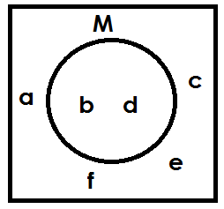

(a) Find (M) **I**

(b) List all the elements of M

(c) List all the elements in the universal set.

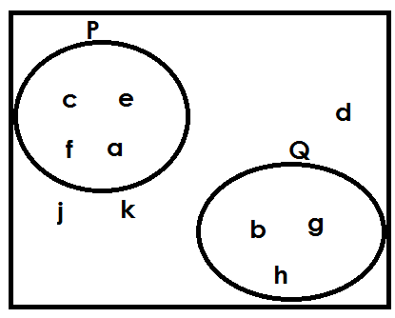3.

(a) List all elements in P

(b) List all elements in Q

(c) Find P complement?

(d) Find Q complement?

(e) Find PUQ complement?

(f) List all members in the universal set.

**Describing shaded and un shaded regions of a Venn diagram**

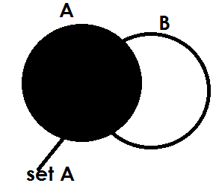 **Examples**

1.

Or set (B-A)’

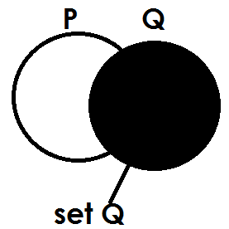

2.

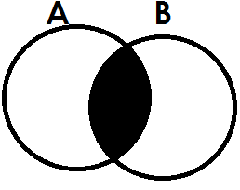

3.

A n B

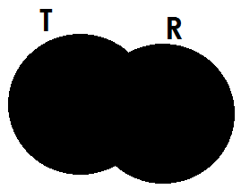 Set A intersection set B

4.

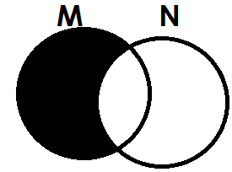 TUR or (Set T union set B)

5.

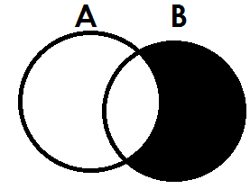 M - N or M only or N **I**

6.

B-A or B only or A’

****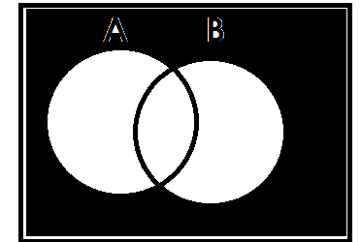7.



(A u B) **I** or - A u B

****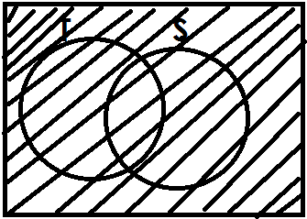8.

Universal set

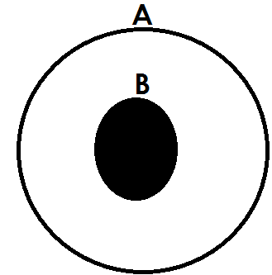9.

A n B or BCA or set B

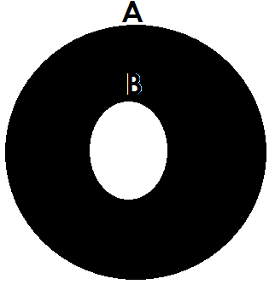10.

A only/ (A n B) **I** /B **I** / A - B

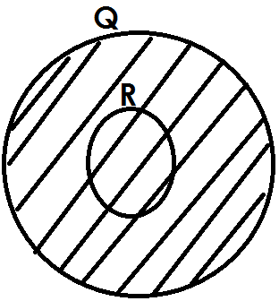11.

 QUR

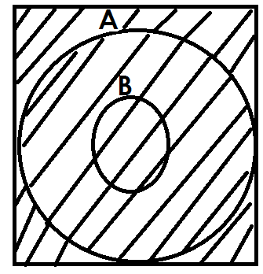12.



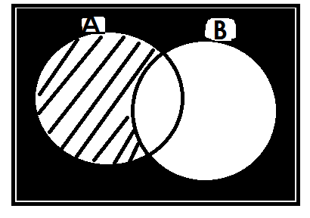13.

B **I**

****14.

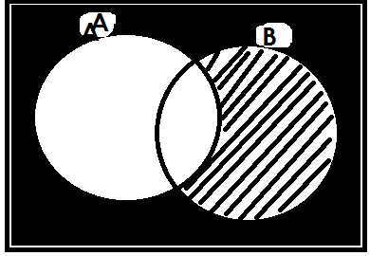

A **I**

**Activity**

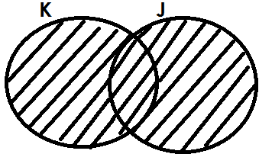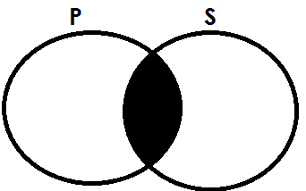 Describe each of the shaded regions in the Venn diagrams below.

1. 2.

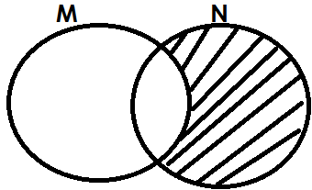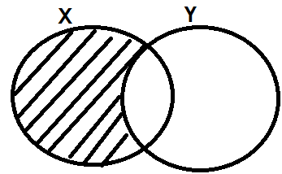

3. 4.

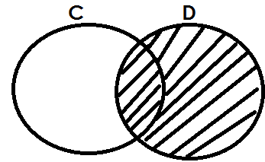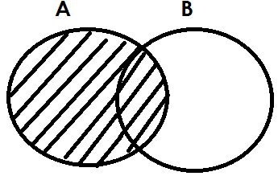5. 6.

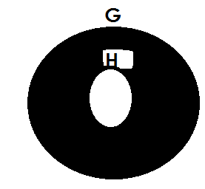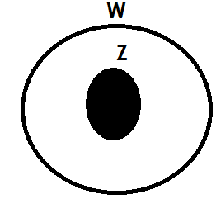

7. 8.

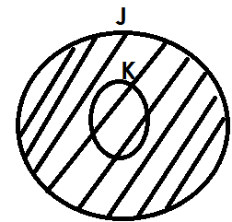****

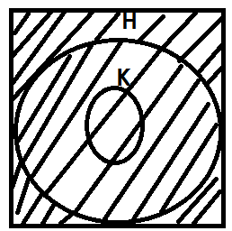9. 9.

****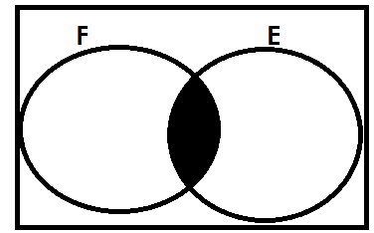

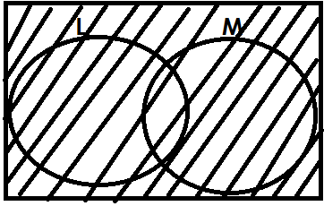11. 12.



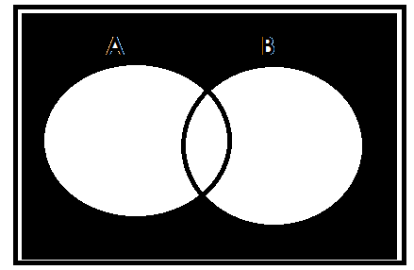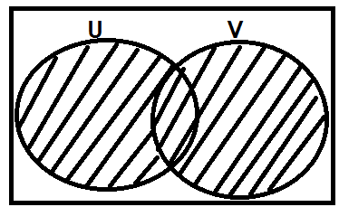13.

14.

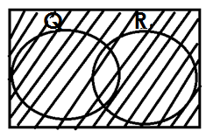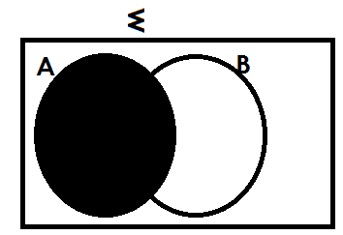15. 16.

**REPRESENTING AND FINDING NUMBER OF ELEMENTS ON A VENN DIAGRAM GIVEN GROUPED DATA**

**Examples**

1. Given that n(A-B) =9, n(B-A) =7, n(A n B)=4 and n(A u B) **I** = 2

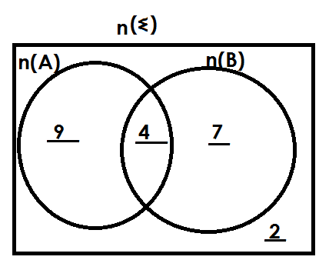(a) Represent both sets on a Venn diagram below

(b) Find

(i) n(A)

n(A)=9+4

=13

(ii) n(B)

n(B)=7+4

=11

(iii) n (A u B) = 9+4+7

= 20

(iv) n (A u B) **I**

n (A u B) **I** = 2

(v) n(A) **I**

n(A) **I** = 7+2

=9

2. If n(X) =15, n(Y) =20, n (X n Y) =8 and n (Xu Y) **I** = 5

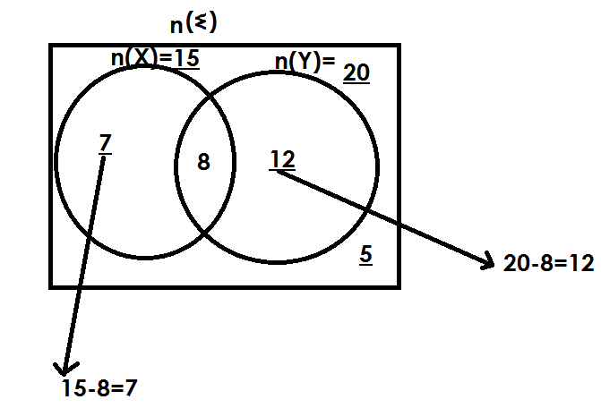(a) **Use the above information to complete the Venn diagram below.**

(b) Find (iii) n (X n Y) **I**

(ii) n(X-Y) soln.

soln. 7+8+12

 7 =24

(ii) n(Y-X) (iv) (v) n

Soln. 7+8+12+5

N(Y-X) =12 =32

3. In a class, 20pupils cat meat (M), 16 eat Fish (F) and 5 eat both while 3 pupils do not eat any of the mentioned.

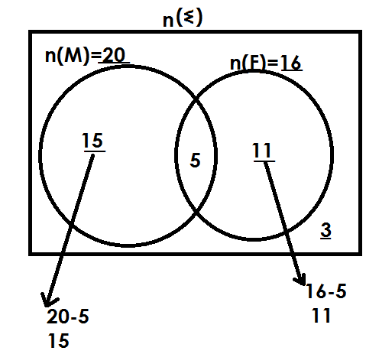(a) Represent the above information on a Venn diagram

(b) How many pupils eat only one dish?

**Solution**

Only one = n(F) only + N(M)only

=15+11

=26 pupils

(c) How many pupils are in the whole class?

** Solution**

=15+5+11+3

=34 pupils

(d) Find the probability of picking a pupil who likes meat only from the class.

**Soln.**

Probability = n (D.C)

n (T.C)

n (D.C) = 20

n (T.C) = 34

Probability =

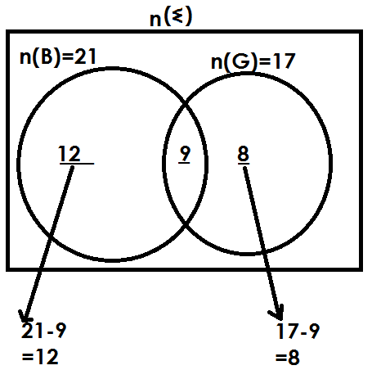4. It is given that; 21 farmers grow beans (B) and 17 farmers grow groundnuts (G). If 9 farmers grow both beans and ground nuts, draw a Venn diagram to show the above information.

(b) how many farmers grow only one type of crop?

Only one = n(B)only + n(G) only

= 12+8

= 20

c. Find the probability of selecting a farmer at random who grows both crops

soln.

Probability =

n (Q.C) = 9

n (T.C) = 12+9+8

= 29

Probability =

**Activity**

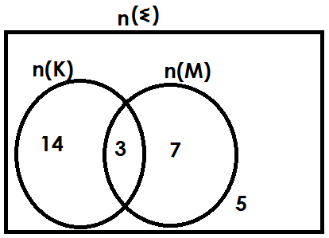1. Use the Venn diagram below to answer questions that follow.

9. Find

(i) n (K) (ii) n(M) (iii) n(K n M)

(iv) n (K u M) (v)

2. Given that n(M)=18, n(N)=25, n (M n N) =10 and n(MUN) **I** =4

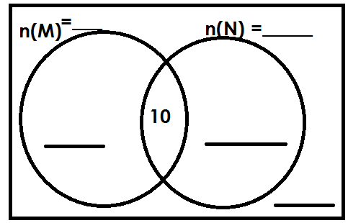(a) Complete the Venn diagram below

(b) Find n(M-N)

(c) Find

3. In a class, pupils made choices of food stuff they prefer. Given rice(R) and Matooke (M). The findings were as follows.

n (R) = 20, n (M) = 28, n (R n M) = 8 and n (R u M) **I** = 2

(a) Draw a Venn diagram representing the above information.

(b) How many pupils chose rice only?

(c) Find the number of pupils who chose matooke only.

(d) How many pupils chose only one type of food?

(e) How many pupils are in that class?

(f) Find the probability of picking a pupil at random who likes rice.

**SOLVING PROBLEMS USING A VENN DIAGRAM**

(a) **GIVEN INTERSECTION AS THE UNKNOWN**

**Example**

In a village of 40 farmers, 26 grow beans (B) 24 grow maize (M) and x farmers grow both crops.

(a) Complete the Venn diagram

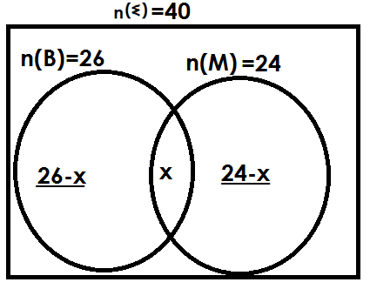

(b) Find the value of x.

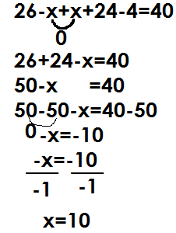 Solution

(c) How many farmers grow only one crop?

Solution

Only one = n (B) only+ n (M) only

= 26 - x + 24 - x

= 26-10+24-10

= 16 + 14

= 30 farmers

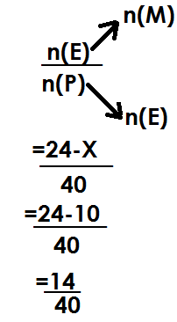(d) Find the probability of picking a farmer who grows maize only from the village

Prob=

**Example2**

In a bus of 50 passengers, 30 bought water (W), 26 bought soda(S) and M passengers bought both drinks while 8 passengers did not buy any of the mentioned.

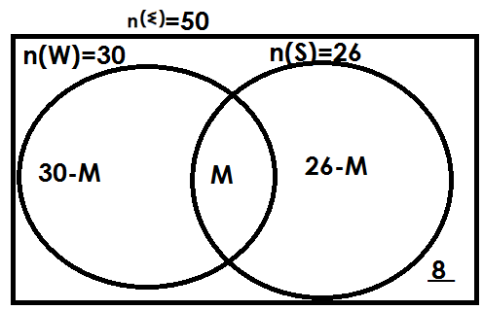(a) **Complete the Venn diagram**

(b) How many passengers bought both drinks?

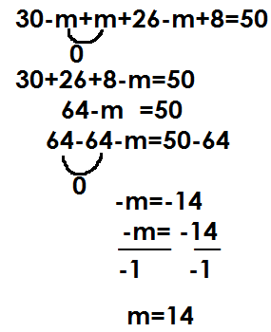 **Soln.**

passengers

(c) How many passengers did not buy water?

**Soln.**

n(W) **I** = 26-m+8

= 26-14+8

= 12+8

= 20

(d) Find the probability of picking a passenger who bought only one drink.

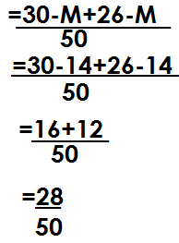 Prob=

**Activity**

1. In a class of 60 pupils, 40 like Math (M), 30 like English (E) and K pupils like both subjects

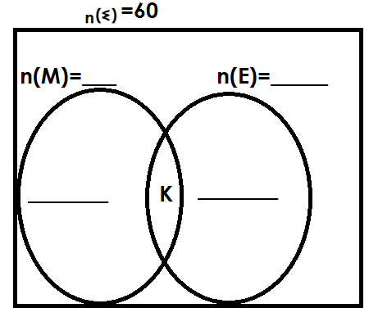a) Complete the Venn diagram

(b) Find the value of K.

(c) How many pupils like only one subject?

(d) Find the probability of picking a pupil who likes Maths only to lead a prayer.

2. In a group of 30 people, 20 eat meat (M), 15 eat fish (F) and y people eat both dishes.

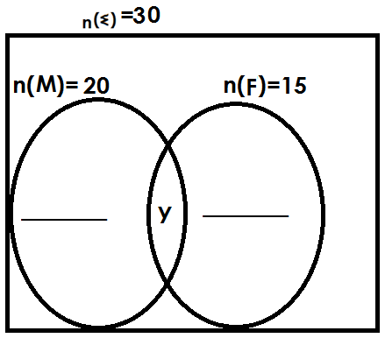(a) Complete the Venn diagram below using the above information.

(b) How many people like both dishes?

(c) How many people eat only one dish?

(d) Find the probability of picking a person who eats fish only from the group at random.

3. In a village of 40 farmers, 30 grow beans (B) 20 grow maize (M) and y farmers grow both crops while 6 farmers do not grow any of the mentioned crops.

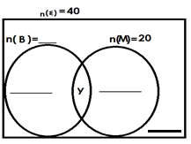(a) Complete the Venn diagram.

(b) Find the value of y.

(c) How many pupils do not grow maize?

(d) Find the probability of picking a farmer who grows only one crop.

4. At a party attended by 60 people, 35 ate chicken(C), 30 ate meat (M) and K people ate both dishes while 5 people ate neither of the two.

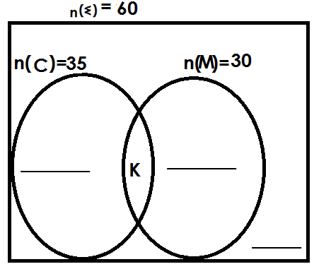(a) Complete the Venn diagram using the above information.

(b) How many people ate both dishes?

(c) Find number of people who ate only one dish.

(d) Find the probability of picking a person who did not eat chicken at the party.

5. In a school of 200 pupils,150 play football (F) 100 play volley ball(V)X pupils play both and 40 pupils play neither of the two.

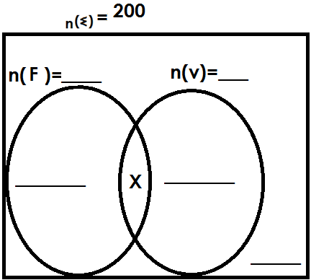(a) Complete the Venn diagram.

(b) Find the value of X

(c) How many pupils play only one game?

(d) Find the probability of picking a pupil who does not play football from the school at random.

**SOLVING PROBLEMS USING A VENN DIAGRAM**

(B) **GIVEN ONE OF THE SETS AS THE UNKNOWN**

**Example 1**

In a class of 30 pupils K pupils like math (M), 18 like English (E) and 5 pupils like both subjects while 3 pupils like neither of the two.

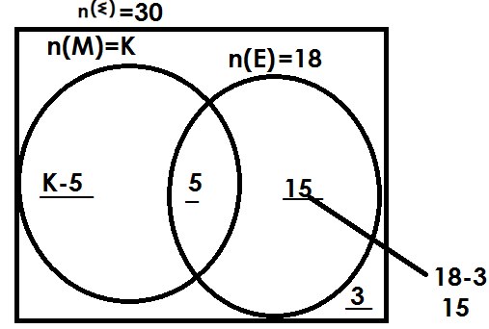(a) Complete the Venn diagram

(b) Find the value of K

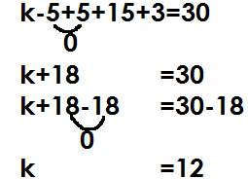 Soln.

(c) How many pupils like only one subjects

**Soln.**

Only one = n (M) only+ n (E) only

= k-5+15

= 12-5+15

= 7+15

= 22 pupils

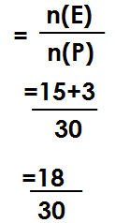(d) Find the probability of picking a pupil who does not like Maths (M) from the class.

Prob

**Example 2**

In a village of 50 farmers, 20 grow maize (M), 2P farmers grow beans (B) and 10 farmers grow both crops while 4 farmers do not grow any of the mentioned.

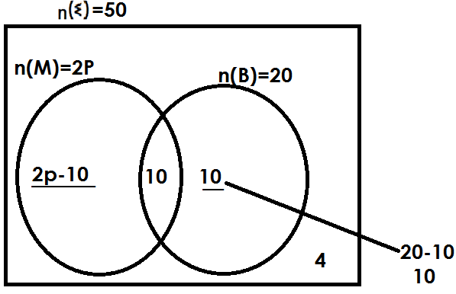(a) Complete the Venn diagram

(b) Find the value of P

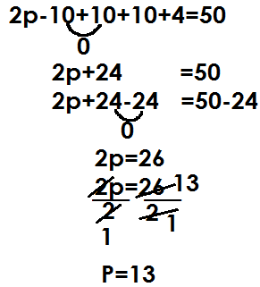 **Solution**

(c) How many farmers grow only one crop?

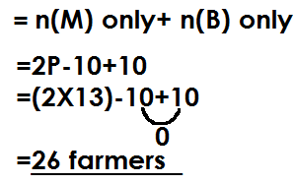 **Solution**

Only one

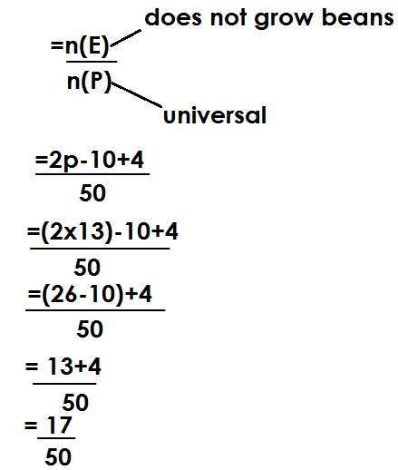(d) Find the probability of picking a farmer who does not grow beans

prob

**ACTIVITY**

1. In a group of 40 people, K people took water (W), 15 people took soda(S) and 5 people took both drinks while 8 people did not take any of the mentioned drinks.

(a) Complete the Venn diagram.

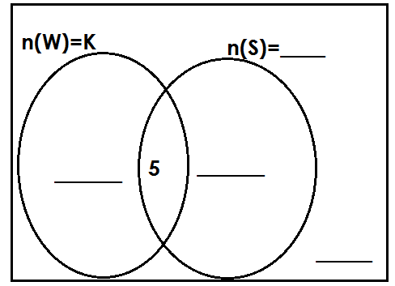

(b) Find the value of k.

(c) How many people took only one drink?

(d) Find the probability of picking a person who did not take water from the group.

2. In a class of 56 pupils, 26pupils like English (E), X pupils like Math(M) 10 pupils like both subjects and 6 pupils like none of the mentioned.

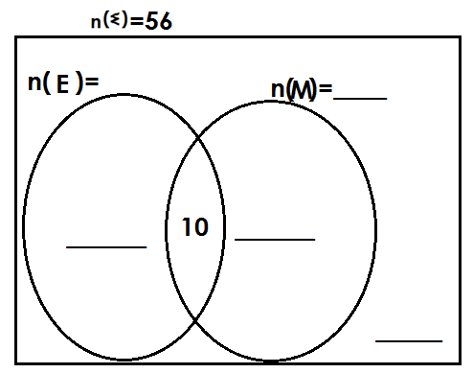(a) Complete the Venn diagram.

(b) How many pupils like Math (M)?

(c) How many pupils like only one subject?

(d) Find the probability of picking a person who does not like English.

3. At a birthday party attended by 70 people, 2m people ate meat (M),30 people ate fish(F) and 8 people ate both dishes, while 2 people did not eat any of the mentioned.

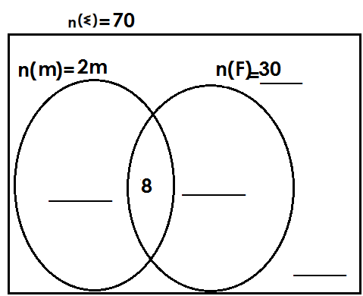(a) Complete the Venn diagram

(b) Find the value of m.

(c) How many pupils eat only one dish?

(d) How many pupils do not eat fish?

4. In a market of 40 traders, y traders sell shirts (S, 15 traders sell dresses(s) and 6 traders sell both types while 4 traders do not sell any of the mentioned.

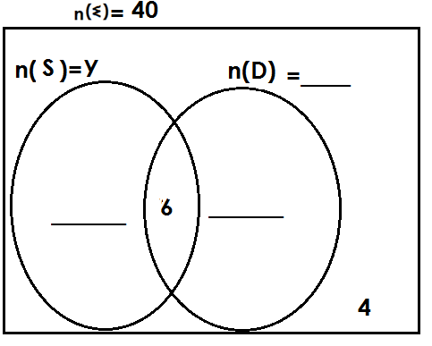(a) Complete the Venn diagram

(b) Find the value of y

(c) How many traders sell only one type of clothes?

(d) Find the probability of picking a trader who sells shirts only.

**SOLVING PROBLEMS USING A VENN DIAGRAM**

**(C) GIVEN DIFFERENCE OF SETS AS THE UNKNOWN**

**Example1**

In a village of 46 farmers, K farmers grow rice only (R), 24 farmers grow maize (m) and 7 farmers grow both crops while 3 farmers do not grow any of the mentioned.

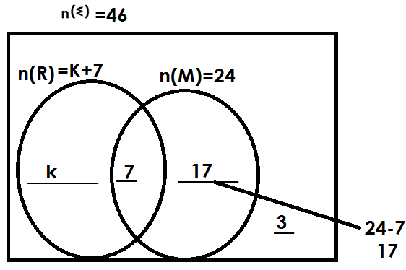(a) Complete the Venn diagram.

(b) Find the value of k

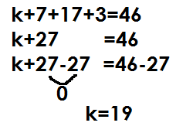 **Solution**

(c) How many farmers grow only one crop?

**Solution**

Only one = n (m) only+ n (R only)

= k+17

= 19+17

= 36 farmers

(d) How many farmers grow rice?

**Solution**

n(R) = k+7

= 19+7

= 26

**Example2**

In a class of 64 pupils, 2y pupils like math only (M), 24 pupils like English only (E) 10 pupils like both subjects and 4 pupils do not like any of the mentioned.

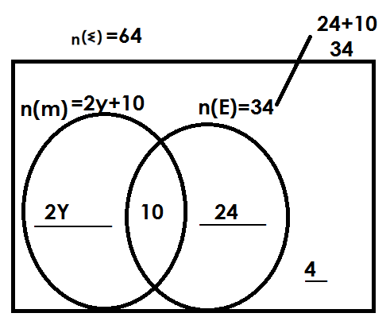(a) Complete the Venn diagram

(b) Find the value of y.

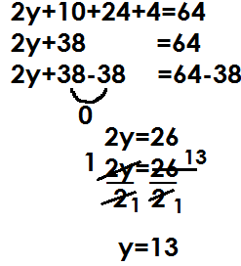 **Solution**

(c) How many pupils like math?

**Solution**

n(m) = 2y+10

= (2x13) +10

= 26+10

= 36

(d) Find the probability of picking a pupil who likes only one subject.

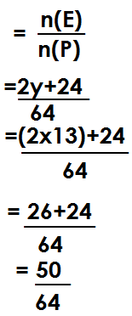 **Solution**

Prob

**ACTIVITY**

1. In a village of 42 farmers, 20 farmers grow maize (M), y farmers grow beans (B) only and 6 farmers grow both while 2 farmers do not grow any.

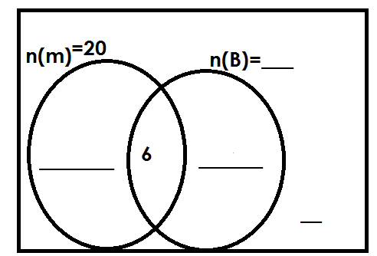(a) Complete the Venn diagram.

(b) Find the value of y.

(c) How many farmers grow only one crop?

(d) Find the probability of picking a farmer who grows beans from the village.

2. In a class of 48 pupils, 18 like Matooke(M) only. K like Posho (P) only, 12 like both Matoke and Posho while 3 pupils do not like any of the two.

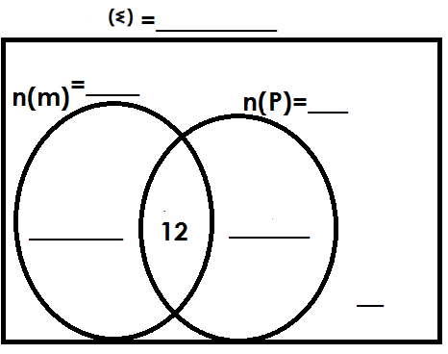(a) Complete the Venn diagram below.

(b) Find the value of K

(c) How many pupils like only one type of food?

(d) Find the probability of selecting a pupil at random who likes both matooke and posho to be the class captain.

3. In a village of 54 people, 2p grow crops(C) only, 40 people rear animals (A), 10people grow crops and rear animals, while 4 people do not do either.

(a) Complete the Venn diagram below

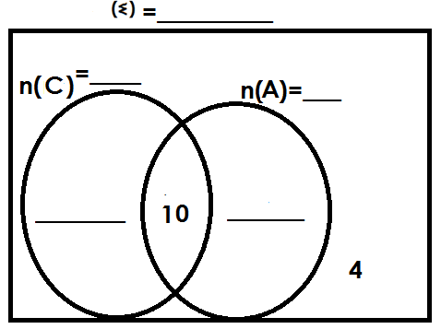

(b) Find the value of P

(c) If a person is picked at random, what is he chance that a person picked grows?

(i) Both crops

(ii) One crop only.

4. The Venn diagram below represents a class of 56 pupils. Given that 26 pupils like SST (S), (2m+4) pupils like RE (R) only, 8 pupils like both subjects and 4 pupils do not like either.

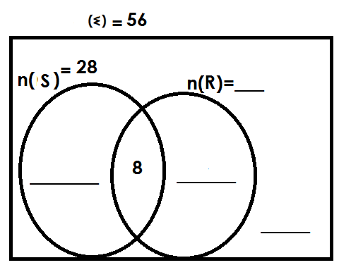(a) Complete the Venn diagram

(b) Find the value of m.

(c) How many pupils like one subject only?

**NUMERATION SYSTEMS AND PLACE VALUES**

**PLACE VALUES AND VALUES OF WHOLE NUMBERS**

**PLACE VALUE**

Place value is the position of a given digit in a given numeral.

Place values of whole digits end in letter “s”

Find the place value of each digit in the following

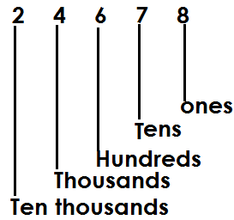a)

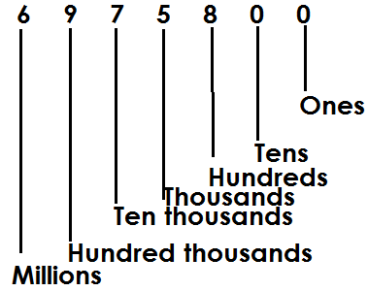b). 6975800

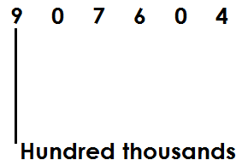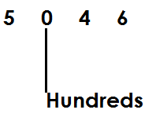Finding the value of the underlined digits in the above numerals

(a) (b)

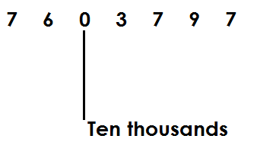

(c)

**Activity**

1. Find the place value of each digit in the following

(a) 3467 (b) 907076 (c) 30464 (d) 9076036

2. Find the place value of the underlined digits.

(a) 904 (b) 6706 (c) 30467

(d) 907,632 (c) 1,036,011

**FINDING VALUES OF WHOLE NUMBERS IN GIVEN NUMERAL**

A value is how manyness of a given digit in a given numeral.

Value is got by multiplying a digit by is place value.

Value = digit x place value.

1. Find the value of each digit in the following.

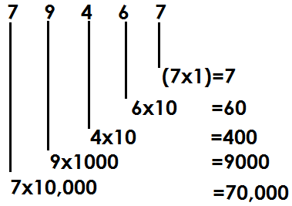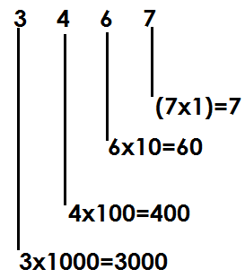a) b)

3. Find the value of digit 5 in the number

23568

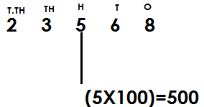**Solution**

**ACTIVITY**

1. Find the value of each digit in the following numbers

(a) 423 (b) 6834

(c) 20168 (d) 24019

2. Find the value of underlined digits in the following numbers.

(a) 463 (b) 2018 (c) 13249

3. Find the value of digit 4in 3456.

**FINDING SUM, DIFFERENCE, PRODUCT AND QUOTIENT OF DIGITS IN A GIVEN NUMBER.**

**Sum**- the answer got after adding the given numbers.

**Difference**- the answer obtained after subtracting

**Product**- the result of multiplication

**Quotient**- the result of division.

**Examples**

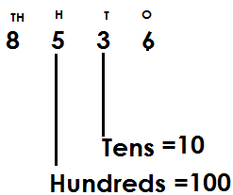1. Given the number 8536. Find the sum of the place value of 3 and place value of 5

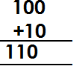 **Sum =**

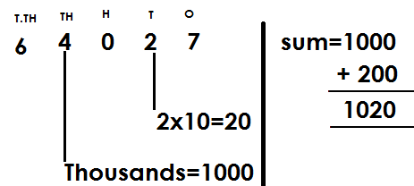2. What is the sum of the place value of 4 and the value of 2 in 64027?

3. Find the difference between the place value of 8 and the value of 6 in 8067.

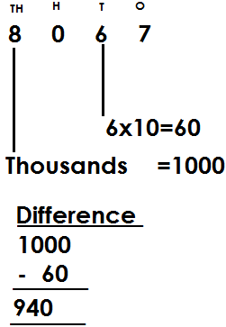 **Solution**

4. Find the product of the place value of 5 and the value of 2 in the number 4563.

**Solution**

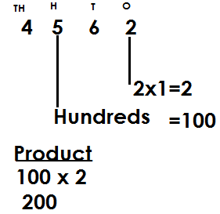

5. Find the quotient of the place value of 5 and the value of 2 in 75820.

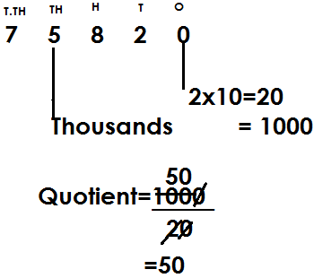 **Solution**

**ACTIVITY**

1. Given 4635. Find the sum of a place value of 4 and place of 3.

2. Find the sum of the value of 6 and value of 4 in 93461.

3. Find the difference between the place value of 8 and the value of 5 in 8057.

4. What is the difference between the value of 3 and the place value of 4 in 7324?

5. Find the product of the place value of 2 and the value of 3 in 42673?

6. Given the number 97265, find the quotient of the value of 7 and 5.

7. Given the number 8536, find the product of a place value of 3 and place value of

**EXPANDING WHOLE NUMBERS**

Whole numbers are expanded in three ways.

1. Using place values

2. Using value

3. Using powers/indices/exponents

**Examples**

1. Expand 208 using place values

**Solution**

= (2x100) + (0x10) + (8x1)

2. Expand 439 using values

 **Solution**

= (4x100) + (3x10) + (9x1)

= 400 + 30 + 9

3. Expand 650 using exponents

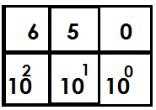 **Solution**

= (6x102) + (5x101) + (0x100)

**Activity**

1. Expand the following numbers using place values

(a) 432 (b) 1068 (c) 4674

2. Expand the following numbers using values

(a) 68 (b) 468 (c) 2074

3. Expand the following numbers using exponents

(a) 146 (b) 4023 (c) 1742

**DECIMAL NUMBERS**

These are numbers with a decimal point and decimal places.

**Note**

Decimals are also fractions whose denominators are multiples of ten.

Examples of decimals

2.356 , 0.04, 0.4, 346.9

**Illustration**

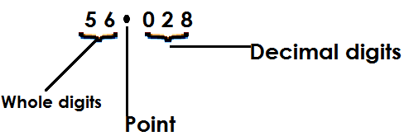 Given 56.028

* To the left of a decimal point, there are whole numbers and to the right, there are decimal numbers (fractions)
* Decimal places are the number of digits after a decimal point.

**Place values of decimal digits**

These include;

(i) Tenths

(ii) Hundredths

(iii) Thousandths

(iv) Ten thousandths

(v) Hundred thousandths

**Note**

(i) Decimal place values end in letters “ths.”

(ii) Decimal place values are given and written from left to right.

**Example**

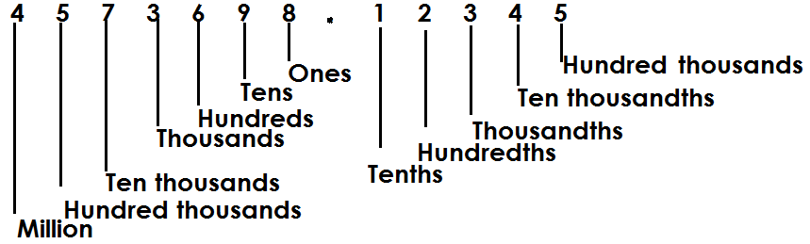1. Identify the place value of each digit in the umber 4573698.12345

2. Find the place value of 2 in 87.629

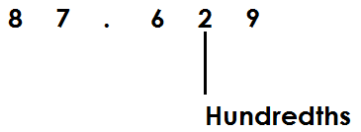 **Solution**

3. What is the place value of the underlined digit in 45.168

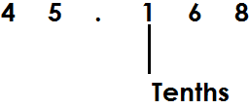 **Solution**

**Activity**

1. What is the place value of 0 in 4.506?

2. Name the place value of 6 in 962.8

3. What is the place value of the underlined digits in the following?

(a) 0.375 (b) 45.168 (c) 8.9753 (d) 0.0009 (e) 0.1235

**VALUES OF DECIMAL DIGITS**

**Note:**

A value is a product of a digit and its place value

i.e.

**GUIDING TABLE**

|  |  |
| --- | --- |
| **Words** | **Figures** |
| Tenths |  |
| Hundredths |  |
| Thousandths |  |
| Ten thousandths |  |
| Hundred thousandths |  |

**Examples**

1. Find the value of 4 in 0.341

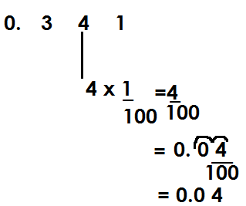 **Solution**

2. Find the value of the underlined digit in the number 0. 0 4 7

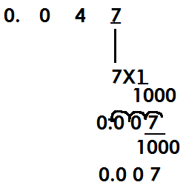 **Solution**

**Activity**

1. Find the value of 2 in 0.234

2. Find the value of the underlined digits in the following:

(a) 12.64 (b) 6.02

(c) 123.681 (d) 43.56

(e) 124.586 (f) 0.0086

(g) 6842.3579 (h) 14.6

**FINDING SUM, DIFFERENCE, PRODUCT AND QUOTIENT OF DIGITS IN GIVEN NUMBERS.**

**Examples**

1. Find the sum of the values of 2 and 3 in 0.342

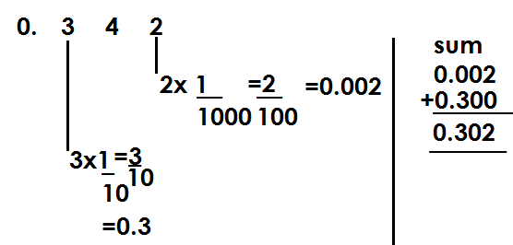 **Solution**

2. Find the difference between the values of 4 and 7 in 24.067

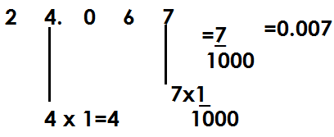 **Solution**

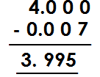**Difference**

3. Find the quotient of the values of 2 and 4 in the number 12.4

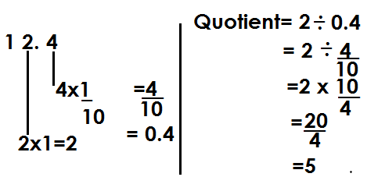 **Solution**

**Activity**

1. Find the sum of the values of 4 and 3 in 0.463

2. Find the sum of the values of 3 and 6 in 73.26

3. Find the difference of the values of 4 and 7 in 24.067.

4. Find the difference of the values of 5 and 4 in 75.649

5. Find the product of the values of 2 and 4 in 12.4.

6. Find the quotient for the values of 4 and 2 in 14.2

7. Find the sum of the values of 3 and 6 in 73.26.

**EXPANDING DECIMAL NUMBERS**

Decimal numbers are expanded using:

(a) Place values

(b) Values

(c) powers/exponents/indices

**Expanding decimal numbers using place values**

**Examples**

Using place values, expand the following

(a) 0.739

**Solution**

(0x1) + (7 x) + (3 x) + (9 x)

(b) 0.08

**Solution**

(0x1) + (0 x) + (8 x )

(c) 123.456

**Solution**

(1x100) +2x10+ (3x1) +4x) + (5X) + (6x)

(d) 208.763

**Solution**

(2x100) + (0x10) + (8x1) + (7x) + (6x) + (3x)

(e) 9.457

**Solution**

(9x1) + (4x) + (5x) + (7x)

**Activity**

1. Expand 2.43 using place values.

2. Express 69.241 in expanded form using place values.

3. Expand the following using place values

(a) 0.034 (b) 342.52 (c) 97.304 (d) 402.347

**Expanding decimal numbers using values.**

**Examples**

1. Expand 34.6 using values

34.6

**Solution**

= (3x10) + (4x1) + (6x)

= 30 + 4 +

= 30 + 4 + 0.6

2. 69.23

**Solution**

69.23

= (6x10) + (9x1) + (2x) + (3x)

= 60+9+0.2+0.03

3. 7.864

**Solution**

= 7. 864

= 7 x 1 + + +

= 7 + 0.8 + 0.06 + 0.04

4. 0.063

**Solution**

0.063

= (0x1) + + +

= 0 + 0 + 0.06 + 0.003

**ACTIVITY**

**Expand the following decimal numbers using values.**

1. 4038.12

2. 0.32

3. 39.764

4. 2.3

5. 0.009

6. 72.63

**Expanding numbers using exponents/powers**

**Examples**

1. Expand 49.35 using powers.

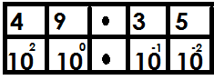 49.35

= (4x102) + (9x100) + (3x10-1) + (5x10-2)

2. 184.009

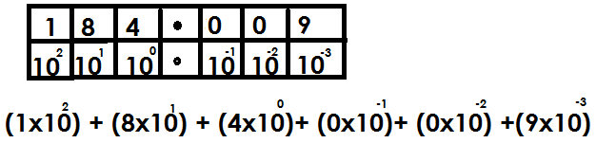

**Activity**

Express the following decimal numbers in expanded form using exponents.

1. 0.576

2. 159.38

3. 0.0008

4. 400.002

5. 2018.2019

6. 44.0782

7. 67.07

**WRITING EXPANDED DECIMALS AS SINGLE NUMBERS**

**Note:**

A given expanded decimal number is again expanded up to value form and later values obtained are added to get a single expanded number

**Examples**

1. Which numbers were expanded to give the following?

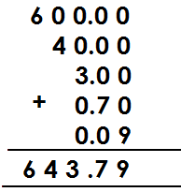(a) 660+40+3+0.7+0.09

b) 700+5+0.08

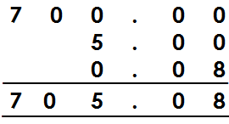 **Solution**

c) (4x10) + (3x1) + (8x) + (5x)

= 40 + 3 + +

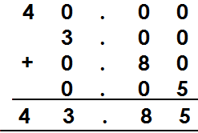= 40+3+0.8+0.05

d) (3x100) + (7x1) + (2x) + (9x)

**Solution**

= 300+7+ +

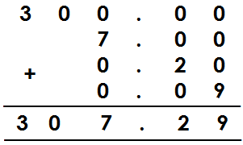= 300+7+0.2+0.09

e) (4x10) + (8x) + (0x) + (9x)

Solution

= 40+ + +

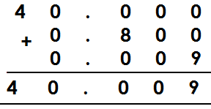= 40+0.8+0+0.009

**Activity**

Which numbers have been expanded to give?

1. 70+1+0.3+0.01

2. 900+30+8+0.5+0.06+0.007

3. 80+0.08+0.003

4. (1x100) + (4x10) + (3x1) + (6x) + (7x)

5. (4x1000) + (0x100) + (8x1) + (1x) + (2x) + (6x)

6. (0x1) + (0x) + (0x) + (9x)

7. (3x100) + (9x10) + (4x) + (7x)

**MORE ABOUT WRITING EXPANDED DECIMALS AS A SINGLE NUMBER**

**Examples**

1. Which number was expanded to give the following?

(a)

Solution

(3x10x10) + (5x10) + (4x1) + (8x)

300+50+4+

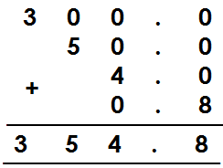 300+50+4+0.8

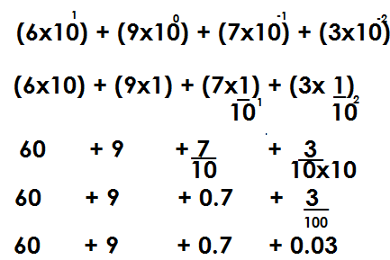(b)

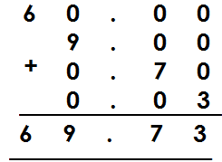

**Activity**

 Which number was expanded to give the following?

1.

2.

3.

4.



5.

**ROUNDING OFF OF WHOLE NUMBERS**

**Note:**

Rounding off is a way of approximating numbers to the required place values.

**ROUNDING OFF WHOLE NUMBERS**

* In rounding off, focus on the digit on the right of the figure in the required place value to either roundup or round down.
* Round down in case the digit on the right of the figure in the required place value is either,0,1,2,3, or 4 by adding 0 to the digit in the required place value.
* Roundup in case the digit on the right of the figure in the required place value is either 5, 6, 7, 8, or 9 by adding the value of the digit in the required place value.
* All digits coming on the right of the digit in the required place value will turn into zero (0) when rounding off of whole numbers.

**Examples**

1. Round off 24643 to the nearest hundreds.

Tth Th H T O

2 4 6 44 3

0

2 4 6 0 0

 24643 24600

2. Round off 4867 to the nearest thousands

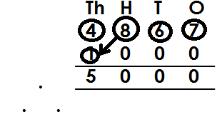 **Solution**

4867 5000

3. Round off 75 the nearest hundreds

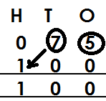 **Solution**

75

75 100

**Activity**

1. Round off to the nearest tens

(a) 24 (b) 337 (c) 4689 (d) 214

2. Round off to the nearest hundreds

(a) 263 (b) 586 (c) 1721 (d) 9296

3. Round off to the nearest thousands

(a) 8634 (b) 1945 (c) 57389 (d) 8634

**ROUNDING OFF DECIMAL NUMBERS**

**Note: -**

While rounding off decimals, all digits coming after the figure in the required place value are crossed out. I.e. the last digit must be in the mentioned place value.

Rounding off to the nearest whole numbers means to round off to the place value of ones.

Rounding off to one decimal place means to the place value of tenths.

Rounding off to two decimal places means to the place value of hundredths.

Rounding off to three decimal places means to the place value of thousandths.

**Examples**

Round off 39.45 to the nearest tenths

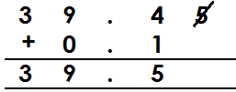

 39.45 39.5

Correct 97.656 to 1 decimal place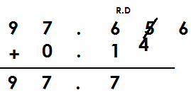

97.656 97.7

Round off 89.996 to the nearest hundredths

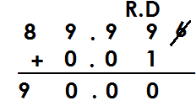



89.99 90.00

Round off 99.8907 to two decimal places

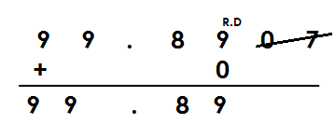**Solution**

99.8907 99.89

**Example 4**

Round off 99.46 to the nearest whole number

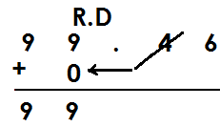 **Solution**

99.46 99

Round off 599.657 to the nearest whole number

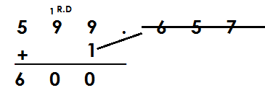 **Solution**



599.657 600

**Activity**

1. Round off the following to one decimal place

(a) 54.67 (b) 503.906 (c) 576.96 (d) 709.63

2. Round off the following to the nearest tenths

(a) 907.63 (b) 123.99 (c) 54.076

3. Round off the following to the nearest hundredths

(a) 40.986 (b) 49.586 (c) 50.764

4. Round off 69.465 to 2 decimal places

5. Round off 909.3976 to the nearest thousandths.

**WRITING NUMBERS IN STANDARD FORM/SCIENTIFIC NOTATION**

Standard form is a way of expressing numbers as a product of powers of ten leaving one counting digit in the places of whole.

The number of steps moved by a decimal point will determine the size of powers.

If a decimal point moves taking a left direction, a positive power is obtained.

If a decimal point moves taking the right direction, a negative power is obtained.

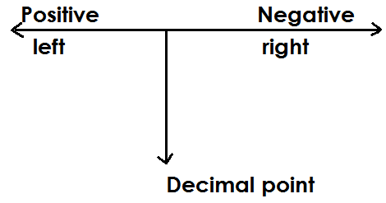 **Illustration**

**Example 1**

Write 843 in scientific notation

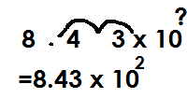 **Solution**

843=

**Example2**

Write 96.3 in standard form

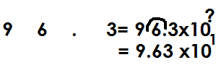 **Solution**

96.3=

**Example 3**

Write 4676.16 in scientific form

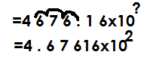 **Solution**

4676.16=

**Example 4**

Express 0.246 in standard form.

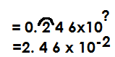 **Solution**

0.246=

Express 0.00478 in scientific notation

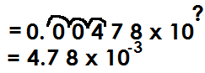 **Solution**

0.00478=

Express 420000 in scientific notation

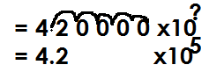**Solution**

420000=

Express 4.9 in standard form

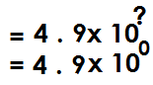**Solution**

4.9

**Activity**

1. Express following in standard form

(a) 423 (b) 3967 (c) 497.3

(d) 97.04 (e) 9.6 (f) 560000

2. Write the following in standard form

(a) 0.96 (b) 0.09 (c) 0.00789

(d) 0.0499 (e) 0.008637

**FINDING ORIGINAL NUMBERS THAT WERE WRITTEN IN STANDARD FORM**

**Example 1**

Find the number that was written in standard form to give 8.73x102?

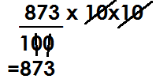 **Solution**

8.73x102 =

**Example 2**

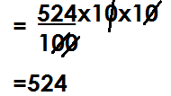Which number was written in standard form to give 5.24x102?

5.24x102

Find the number that was written in standard form to give 9.6x10-2

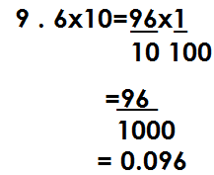**Solution**

Find the original number that was written inn scientific form to give 6x106?

**Solution**

6x106 = 6 x10x10x10x10x10x10

= 6x1000000

= 6000000

**Example 4**

Which number was written in standard form to give 6.234x10-5

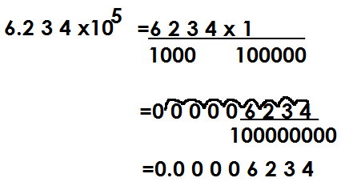**Solution**

**Activity**

1. Find the number that was written in standard for to give

(a) 4.7x102 (b) 5.4 x103 (c) 5.678 x105

(d) 6.04x103 (e) 7.1x104

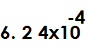2. Which numbers were written in scientific form to given the following?

(a) (b) (c) (d)



(e) (f)

**TYPES OF NUMERALS**

1. Hindu Arabic numerals

2. Roman numerals

**Hindu Arabic numerals**

These are numerals that are used in most parts of the world.

**Major Hindu Arabic numerals**

0,1,2,3,4,5,6,7,8,9

**ROMAN NUMERALS**

1. **Basic Roman numerals**

|  |  |  |  |  |  |  |  |
| --- | --- | --- | --- | --- | --- | --- | --- |
| Hindu Arabic | 1 | 5 | 10 | 50 | 100 | 500 | 1000 |
| Roman numerals | I | V | X | L | C | D | M |

**NOTE:**

* All roman numerals should be written in capital letters.
* All types of Roman numerals are derived from basic Roman numerals.

**2.** **Repeated roman numerals**

They are got by repeating some basic Roman numerals like I, X, C and M

Repeated roman numerals act on digits 2 and 3 in place values of ones, tens, hundreds and thousands.

**(a)** **In the place value of ones**

2 - II

3 - III

**(b) In the place value of tens**

20 - XX

30 - XXX

**(c) In the place value of hundreds**

200 - CC

300 - CCC

**(d) In the place value of thousands**

2000-MM

3000-MMM

**3. Addition Roman numerals**

Addition Roman numerals use digits 6, 7 and 8 in the place values of ones, tens, hundreds.

**(a) In the place value of ones**

6 = 5+1

= VI

7 = 5 + 2

= VII

8 = 5+3

= VIII

**(b) In the place value of tens**

60 = 50 +10

= LX

70 = 50 + 20

= LXX

80 = 50 + 30

= LXXX

**(c) In the place value of hundreds**

600 = 500 +100

= DC

700 = 500 +100

= DCC

800 = 500 + 300

= DCCC

4. **SUBTRACTION ROMAN NUMERALS**

These uses digits 4 and 9 in the place values of ones, tens and hundreds.

(**a) In the place value of ones**

4 = 5 -1

= IV

9 = 10 - 1

= IX

**(b) In the place value of tens**

40 = 50 - 10

= XL

90 = 100 - 10

= XC

**(c) In the place values of hundreds**

400 = 500 - 100

= CD

900 = 1000 -100

= CM

**WRITING NUMBERS IN ROMAN NUMERALS**

1.Write 149 in roman numerals

|  |  |  |
| --- | --- | --- |
| 100 | 40 | 9 |
| C | XL | IX |

149 = CXLIX

2. Write the following in roman numerals

a) 38

|  |  |
| --- | --- |
| 30 | 8 |
| XXX | VIII |

38 = XXXVIII

b) 89

|  |  |
| --- | --- |
| 80 | 9 |
| LXXX | IX |

89 = LXXXIV

c) 499

|  |  |  |
| --- | --- | --- |
| 400 | 90 | 9 |
| CD | XC | IX |

499 = CDXCIX

d) 649

|  |  |  |
| --- | --- | --- |
| 600 | 4 | 9 |
| DC | XL | IX |

649 = DCXLIX

e) 782

|  |  |  |
| --- | --- | --- |
| 700 | 80 | 2 |
| DCC | LXXX | II |

782 = DCCLXXXII

**Activity**

Write the following in Roman numerals

(a) 49 (b) 36

(c) 29 (d) 69

(e) 326 (f) 99

(g) 436 (h) 223

(i) 648 (j) 562

(k) 888 (l) 1999

**Changing from Roman numerals to Hindu Arabic numerals**

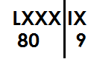1. Write LXXXIX in Hindu Arabic numerals

LXXXIX=

= 89

2. Write the following in Hindu Arabic numerals

|  |  |
| --- | --- |
| X | VIII |
| 10 | 8 |

(a) XVIII

XVIII = 18

b) DCVII

|  |  |
| --- | --- |
| DC | VII |
| 600 | 7 |

DCVII = 607

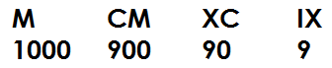(c) MCMXCIX=

1999

**Activity**

(a) XXXVI

(b) XCIV

(c) LVI

(d) CXXXVIII

(e) CDXCVIII

(f) CMXLIX

(g) MMCXI

(h) DCCCLXXXVIII

(j) MMMDCCCLXXXVIII

**WORD PROBLEMS INVOLVING HINDU ARABIC AND ROMAN NUMERALS**

**Examples**

1. Musa was born in 1996. Express his year of birth in roman numerals

|  |  |  |  |
| --- | --- | --- | --- |
| 10000 | 900 | 90 | 6 |
| M | CM | XC | VI |

1996 = MCMXCVI

2. Our teacher is 79 years old. Write his age in Roman numerals

|  |  |
| --- | --- |
| 70 | 9 |
| LXX | IX |

79 = LXXIX

3. Mugisha has CCXLIX animals on his farm. Write his number of animals in Hindu Arabic numerals

|  |  |  |
| --- | --- | --- |
| CC | XL | IX |
| 200 | 40 | 9 |

CCXLIX = 249 animals

4. Mukasa’s great grandfather died in MDCCCLXXXVIII. Write his year of death in Hindu Arabic numerals

|  |  |  |  |
| --- | --- | --- | --- |
| M | DCCC | LXXX | VIII |
| 1000 | 800 | 80 | 8 |

MDCCCLXXXVIII = 1888

**Activity**

1. 2. It is 206km from Town A to town B. Write that distance in roman numerals.
2. Alex was born in 2007. Write his year of birth in roman numerals.
3. There are 108 English books and 73 science books in the library. Write the total number of books in the library.
4. A bag contains XXXIX oranges. Write the number of oranges in Hindu Arabic number.
5. A trader sold CMLXIII bags of cotton. Write the number of bags of cotton in Hindu Arabic numeral.
6. A shop keeper sold XXIV kg of sugar on Monday and LIII kg on Tuesday. Find the total number of kg sold in Hindu Arabic numerals.

**BASES**

A base is a counting system where a particular natural/counting number is taken to be the limit of its counting system.

**Base names**

|  |  |  |
| --- | --- | --- |
| **Base** | **Name** | **Digits used** |
| 2 | Binary | 0,1 |
| 3 | Trinary/ternary | 0,1,2 |
| 4 | quaternary | 0,1,2,3 |
| 5 | Quinary | 0,1,2,3,4 |
| 6 | Senary | 0,1,2,3,4,5 |
| 7 | Septenary/ heptanol | 0,1,2,3,4,5,6 |
| 8 | Octal | 0,1,2,3,4,5,6,7 |
| 9 | Nonary | 0,1,2,3,4,5,6,7,8 |
| 10 | Decimal/Standard/Normal/Denary | 0,1,2,3,4,5,6,7,8,9 |

**PLACE VALUES OF BASE NUMBERS**

**N.B**: The starting place value of base numbers is ones.

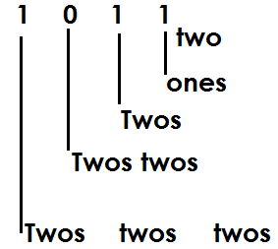1. Write the place value of each digit

a

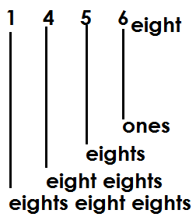b

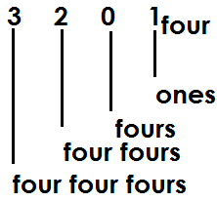c

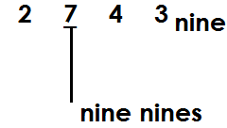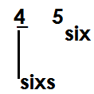Find the place value of the underlined digits.

(a) (b)

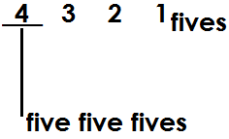(c)

**Activity**

1. Find the place value of each digit

(a) 101two (b) 231 four (c) 4031fives (d) 567 eight (e) 678 nine

2. Find the place value of the underlined digits.

(a) 203four (b) 4031five (c) 367 eight (d) 405 six

**Values of digits in base numbers**

A value is a product of a digit and its place value

Value of a digit = digit x place value

Find the value of 1 in 1000 two

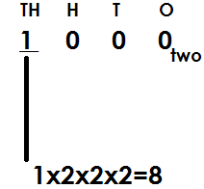 **Solution**

**Example 2**

Find the value of 1 in 100 two

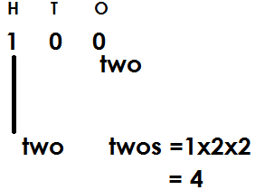 **Solution**

**Example3**

Find the value of 2 in 234 five

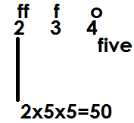 **Solution**

**Example 4**

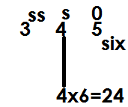Find the value of 4 in 345 six

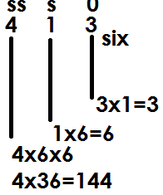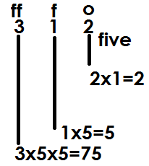Find the value of each digit

(a) (b)

**Activity**

1. Find the value of each digit

(a) 101two (b) 203three

(c) 402five (d) 121three

2. Find the value of the underlined

(a) 102three (b)101two

(c) 7203nine  1101two

**WRITING BASE NUMBERS IN WORDS**

**Note:** Base number digits are read and written independently (one by one) while the base is written last.

**Write the following in words**

1. 1010two

One zero one zero base two

2. 10001

One zero zero zero base two

3. 4302five

Four three zero two base five

4. 6254seven

Six two five four base seven

**Activity**

Write the following base numbers in words

(a) 1000two (b)11111two (c) 2022three (d)7654eight (e) 5454six

**EXPANDING BASE NUMBERS**

**Base numbers are expanded in three ways**

(i) Place values

(ii) Values

(iii) powers/exponents/indices

**Expanding base numbers using place values**

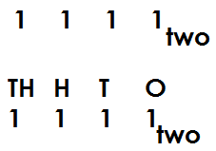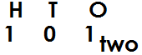Expand the following using place values

(a) (b)

(1x2x2) + (0x2) + (1x1)

(1x2x2x2) + (1x2x2) + (1x2) + (1x1)

(d) 567eight

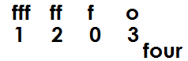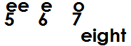(c)

(1x4x4x4) + (2x4x4) + (0x4) + (3x1) (5x8x8) + (6x8) + (7x1)

**Activity**

**Expand the following using place values**

(a) 234five (b) 101two (c) 4201five

(d) 465six (e) 17ten (f) 3102four

**Expanding base numbers using values**

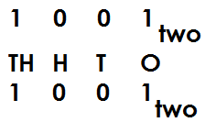Expand the following using values

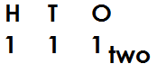(a) (b) 111two

(1x2x2) + (1x2) + (1x1)

(1x2x2x2) + (0x2x2) + (0x2) + (1x1) 4+2+1

8+0+0+1

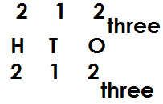 (d)

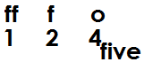(c) 124 five

= (2x3x3) + (1x3) + (2x1)

(1x5x5) + (2x5) + (4x1) 18+3+2

25+ 10+ 4

**Activity**

1. Expand the following base numbers using values

(a) 1010 two (b) 1011two

(c) 10001two (d) 203 four

(e) 103 four (f) 120three

(g) 134five (h) 2231five

(i) 1003five  (j) 435six

**EXPANDING BASE NUMBERS USING POWERS/INDICES/EXPONENTS**

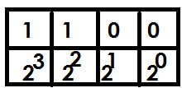1. Expand 1100two using powers.

(1x23) + (1x22) + (0x21) + (0x20)

2. **Expand the following using powers**

(a) 214 five

(b) 102 three

|  |  |  |
| --- | --- | --- |
| 2 | 1 | 4 |
| 55 | 51 | 50 |

|  |  |  |
| --- | --- | --- |
| 1 | 0 | 2 |
| 33 | 31 | 30 |

= (2x52) + (1x51) + (4x50) = (1x32) + (0x31) + (2x30)

|  |  |  |
| --- | --- | --- |
| 1 | 7 | 5 |
| 102 | 101 | 100 |

(c) 175 ten (d) 46 eight

|  |  |
| --- | --- |
| 4 | 6 |
| 81 | 80 |

= (1x102) + (7x101) + (5x100) = (4x81) + (6x80)

**Activity**

1. Expand the following base numbers using powers

(a) 1111two (b) 1001two (c) 1000two

(d) 3012four (e) 212three (f) 5312seven

(g) 43 six (h) 6735nine (i) 257ten

(j) 1010ten

**CONVERSION OF BASE NUMBERS**

**Note:**

Base numbers are converted from;

(a) Base ten/decimal base to other bases/non-decimal bases

(b) Other bases/non-decimal bases to base ten/decimal bases.

(c) Other bases/non-decimal bases t other bases/non-decimal bases.

1. Change 29ten to binary base

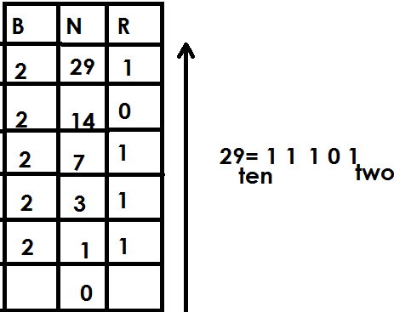

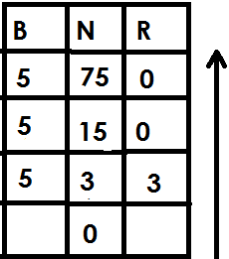2. Change 75ten to quinary base

75ten=300five

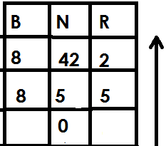3. Babirye scored 42 in a test. Express her marks in octal base

42ten=52 eight

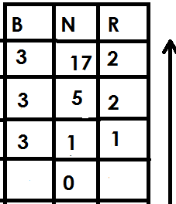4. Mukasa is 17 years old. Write his age in trinary base

17ten=122three

**Activity**

1. Change the following base numbers to the required base

(a) 23ten to binary base

(b) 49ten to binary base

(c) 29ten to base three

(d) 45ten to quinary base

(e) 9ten to ternary base.

(f) 31ten to base four

2. Alex is 19yeaers old. Write his age in binary base.

3. A girl scored 63 marks in a test. Express her mark in nonary base.

4. The teacher is 28years. Write his age in base four.

5. Makanga was born in 2000. Write his year of birth to quinary base system.

**Changing non-decimal base numbers to decimal base**

**Note**

Here we expand a non-decimal base number using powers of the given non-decimal base number

1. Change 1001two to decimal base

|  |  |  |  |
| --- | --- | --- | --- |
| 1 | 0 | 0 | 1 |
| 23 | 22 | 21 | 20 |

= (1x23) + (0x22) + (0x21) + (1x20)

= (1x2x2x2) + (0x2x2) + (0x2) + (1x1)

= 8+0+0+1

= 9ten

2. Change 132five to base ten

|  |  |  |
| --- | --- | --- |
| 1 | 3 | 25 |
| 52 | 51 | 50 |

= (1x52) + (3x51) + (2x50)

= (1x5x5) + (3x5) + (2x1)

= 25+15+2

= 42ten

3. Express 1122three as a decimal base number

|  |  |  |  |
| --- | --- | --- | --- |
| 1 | 1 | 2 | 2 |
| 33 | 32 | 31 | 33 |

= (1x33) + (1x32) + (2x31) + (2x30)

= (1x3x3x3) + (1x3x3) + (2x3) + (2x1)

= 27+9+6+2

= 44ten

**Activity**

1. Change the following non-decimal base numbers to decimal base.

(a) 1111two (b) 1010two (c) 1011two (d) 1100two (e) 1000two

(f) 202 three (g) 123 four (h) 210six (i) 143five (j) 1012five

**CHANGING NON-DECIMAL BASE NUMBERS TO NON-DECIMAL BASE NUMBERS**

**Note:**

First change a non-decimal base number to base ten by expanding then after to the required base by dividing

**Examples**

1. Change 110two to base three

|  |  |  |
| --- | --- | --- |
| 1 | 1 | 0 |
| 22 | 21 | 20 |

= (1X22) + (1X21) + (0X20)

= (1X2X2) + (1X2) + (0X1)

= 4+2+0

= 6ten

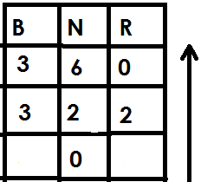

110two = 20three

2. Change 1111two to quinary base.

(1x23) + (1x22) + (1x21) + (1x20)

(1x2x2x2) +1x2x2) + (1x2) + (1x1)

8+4+2+1

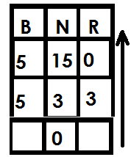15ten

1111two=30five

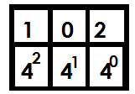3. Change 102four to binary base

(1x42) + (0x41) + (0x40)

(1x4x4) + (0x4) + (0x1)

16+0+1

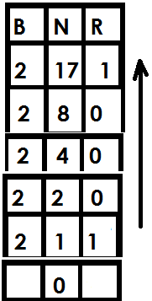17ten

102four=10001two

**Activity**

1. Change the following to the required bases

(a) 1001two to base four

(b) 1000two to base three

(c) 1010two to quinary base

(d) 122three to binary base

(e) 102four to base three

(f) 300four to base five

**FINDING UNKNOWN BASE**

**Examples**

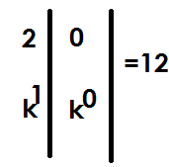1. Find the unknown base in 20k=12ten

(2xk1) + (0xk0) =12

(2xk) + (0x1) =12

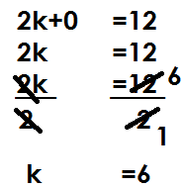

The unknown base is senary.

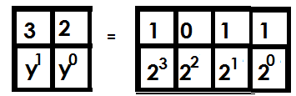2. Find the unknown base if 32y=1011two

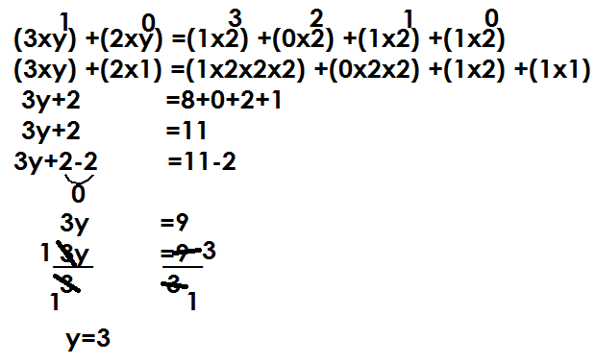

The unknown base is Trinary.

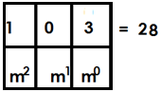3. Find the unknown base if 103m=28

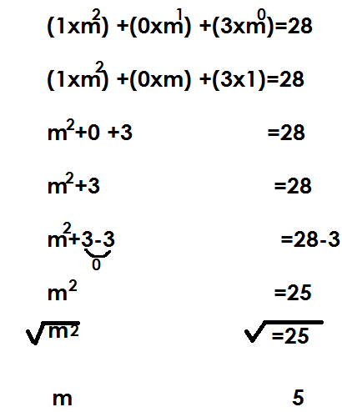

The unknown base is Quinary.

4. If 203k =1222three, find the unknown base

|  |  |  |
| --- | --- | --- |
| 2 | 0 | 3 |
| K2 | K1 | K0 |

|  |  |  |  |
| --- | --- | --- | --- |
| 1 | 2 | 2 | 2 |
| 33 | 32 | 31 | 30 |

=

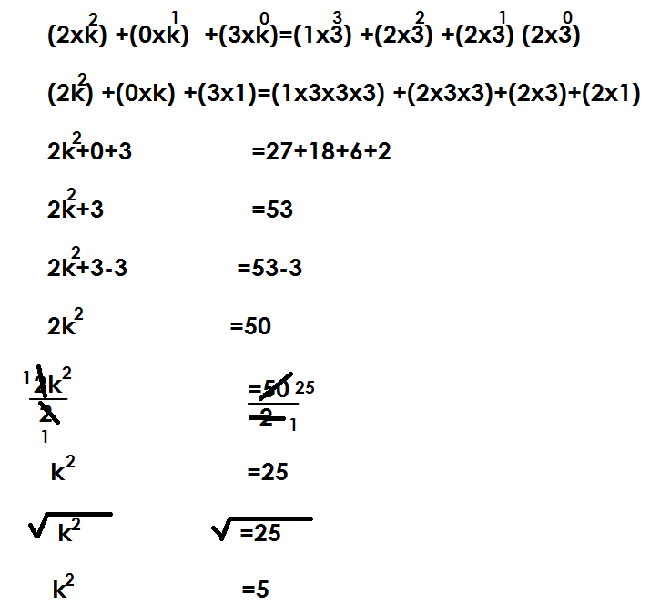

The unknown base is Quinary.

**Activity**

1. Find the unknown bases in the following given that;

(a) 23m=11 (b) 34y=25

(c) 46n=18ten (d) 20k=20three

(e) 50p=30five (f) 102k=1000three

(g) 103x=213four (h) 202k=110100two

(i) 203p=2210three

**ADDITION OF BASE NUMBERS**

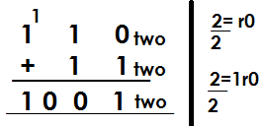1. Add: 110two+11two

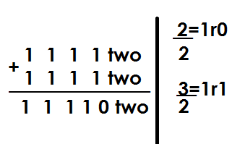2. Add: 1111two+1111two

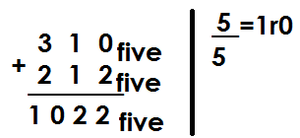3. Workout: 310five+212five

**Activity**

1. Add the following

(a) 1000two + 101two (b) 1100two+ 111two

(c) 1111two +1011two (d) 222three +122three

(e) 413five+321five  (f) 1332four+233four

**SUBTRACTION OF BASES**

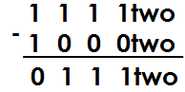1. Subtract: 1111two-1000two

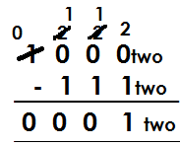2. Workout: 1000two-111two

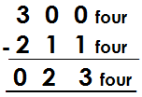3. Workout: 300four-211four

**Activity**

1. Workout the following: -

(a) 1011two-110two (b) 1010two-101two

(c) 202three-21three (d) 321four-132three

(e) 403five-344three (f) 342five-123five

(g) 1000two-111two

**MULTIPLICATION OF BASES**

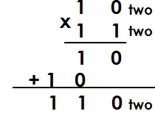1. Multiply: 10twox11two

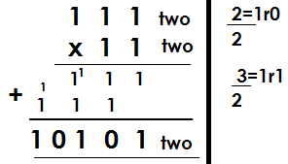2. Workout: 111two x 1 1two

3. Workout: 202three x 12three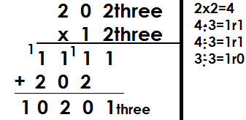

5. Workout: 312four x 32 four

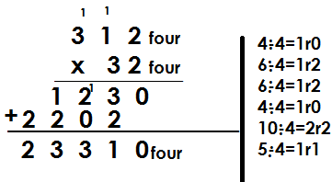4. Multiply: 142five x 43five **solution**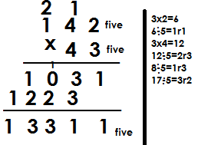

**Activity**

1. Workout the following

(a) 1101two x 11 two (b) 202three x12 three (c) 142five x 32 five

(d) 43 six x 23 six (e) 214 six x 23 six

**DIVISION OF BASES**

**Note:**

* Change the non-decimal bases to decimal bases
* Divide numbers in base ten
* Change the quotient in the given base.

1. Workout the following

(a) 103nine 15 nine

|  |  |  |
| --- | --- | --- |
| 1 | 0 | 3 |
| 92 | 91 | 90 |

|  |  |
| --- | --- |
| 1 | 5 |
| 91 | 90 |

÷

(1x92) + (0x91) + (3x90) ÷ (1x91) + (5x90)

(1x9x9)+ (0x9) + (3x1) ÷ (1x9) + (5x1)

81+0+3 ÷ 9+5

84 ÷ 14

6ten

Therefore 103nine ÷ 15nine= 6 nine

(b) Workout: 220eight ÷ 14 eight

|  |  |  |
| --- | --- | --- |
| 2 | 2 | 0 |
| 82 | 81 | 80 |

|  |  |
| --- | --- |
| 1 | 4 |
| 81 | 80 |

÷

(2x82) + (2x81) + (0x80) ÷ (1x81) + (4x80)

(2x8x8) + (2x8) + (0x1) ÷ (1x8) + (4x1)

2x64+16+0 ÷ 8+4

128+16+0 ÷ 12

144 ÷ 12

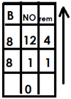 12ten

220 eight ÷ 14 eight=14 eight

Workout: 144five 12 five

|  |  |
| --- | --- |
| 1 | 2 |
| 51 | 50 |

|  |  |  |
| --- | --- | --- |
| 1 | 4 | 4 |
| 52 | 51 | 50 |

÷

= (1x52) + (4x51) + (4x5) ÷ (1x51) + (2x50)

= (1x5x5) + (4x5) + (4x1) ÷ (1x5) + (2x1)

= 25+20+4 ÷ 5+2

= 49 ÷ 7

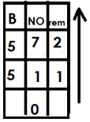= 7ten

Therefore 144 five ÷ 12 five=12 five

Workout: 124six ÷ 21 six

|  |  |  |
| --- | --- | --- |
| 1 | 2 | 4 |
| 62 | 61 | 60 |

|  |  |
| --- | --- |
| 2 | 1 |
| 62 | 61 |

÷

= (1x62) + (2x61) + (4x60) ÷ (2x61) + (1x60)

= (1x6x6) + (2x6) + (4x1) ÷ (2x6) +1x1)

= 36+12+4 ÷ 12+1

= 52 ÷ 13

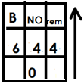= 4ten

4six

**Activity**

1. Workout: 204six ÷ 11five

2. Workout: 330four ÷ 30five

3. Workout: 44five ÷ 111 five

4. Divide 231six ÷ 21six

**NUMBER PATTERNS AND SEQUENCE**

**DIVISIBILITY TEST FOR TWO**

A number is divisible by two if its last digit is even i.e. 0, 2, 4, 6 or 8

**Example1**

Given 321, 2225,661 and 312. Identify a number that is divisible by 2

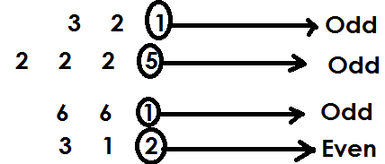 **Solution**

Therefore 312 is divisible by 2 since its last digit is even.

**DIVISIBILITY FOR 3**

A number is divisible by 3 if the sum of its digits is a multiple of 3.

**Example 1**

Given the following numbers, identify a number that is divisible by 3 in

125, 241 and 426

125 sum

1+2+5

8

141 sum

2+4+1

7

426 sum

4+2+6

12

426 is divisible by 3 since the sum of its digit is a multiple of 3.

State whether 111 is divisible by 3

**Solution**

111 sum

= 1+1+1

= 3

Therefore 111 is divisible by 3 since the sum of its digits is a multiple of 3

State whether 241 is divisible by 3

**Solution**

241 sum

= 2+4+1

= 7

Therefore 241 is not divisible by 3 since the sum of its digits is not a multiple of 3.

**Activity.**

1. By showing the working, identify numbers divisible by 3

(a) 236 (b) 245 (c) 462 (d) 4659

2. Given 101, 100, 111 and 110. Without dividing, identify a number which is exactly divisible by 3

**DIVISIBILITY TEST FOR 4**

A number is divisible by 4 if it is even and the number formed by its last two digits is a multiple of 4 or last two digits are (00)

State whether 236 is divisible by 4

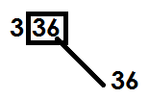 **Solution**

Therefore 336 is divisible by 4 since the number formed by its last two digits is a multiple of 4.

State whether 111112 is divisible by 4

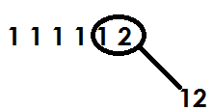 **Solution**

Therefore 111112 is divisible by 4 since the number formed by its last two digits is a multiple of 4

**Example3**

State whether 234 is a multiple by 4

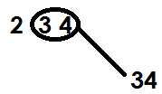 **Solution**

Therefore 234 is not divisible by 4 since the number formed by tits last two digits is a not a multiple of 4.

**Activity.**

State whether the following are divisible by 4

(a) 144 (b) 512 (c) 9444 (d) 568

Without dividing, identify the numbers that are exactly divisible by 4 from:

62748, 10018, 232332 and 97658

**DIVISIBILITY TEST FOR 5**

A number is divisible by 5 if its last digit is 5 or 0

Given the following numbers, 556,104 and 205. Which number is divisible by 5?

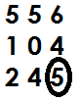 **Solution**

Therefore 245 is divisible by 5 since its last digit is 5

Which of the numbers below is exactly divisible by 5

503, 155,200 and 107

155 and 200 ends in either 0 or 5 and are divisible by 5.

**Activity**

Without dividing, identify numbers that are exactly divisible by 5 by the following.

(a) 15,27,30,38 and 45

(b) 1115, 5504 and 1053

**DIVISIBILITY TEST FOR 6**

A number is divisible by 6 if it is even and also divisible by 3

1. State whether 426 is divisible by 6.

**Solution**

4+2+6=12

Therefore 426 is divisible by 6 since it is divisible by 2 and 3

2. State whether 576 is divisible by 6

**Solution**

576----5+7+6

18

576 is divisible by 6 since it is divisible by 2 and 3.

3. State whether 646 is divisible by6

646

**Solution**

646 = 6+4+6

= 16

16 is not a multiple or 3.

Therefore 646 is not divisible by 6 since it’s not divisible by 3.

**Activity**

State whether the following numbers are divisible by 6

(a) 936 (b) 463 (c) 12462 (d) 963 (e) 612 (f) 113

**DIVISIBILITY TESTS FOR 7**

A number is divisible by 7 when the last digit of a number is doubled and the result is subtracted from the number formed by the remaining digits and the outcome is divisible by 7.

1. State whether 861 is divisible by 7

**Solution**

861

1+1=2

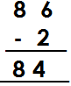

4+4=8

8-8=0

0 is divisible by 7 hence 861 is divisible by 7

2. Find whether 1792 is divisible by7

1792

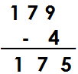 2+2=4

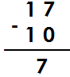 175 ----------5+5=10

7 is divisible by 7 hence 1792 is exactly divisible by 7.

3. State whether 246 is divisible by 7

246

6+6=12

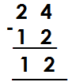

12 is not divisible by 7 hence 246 is not divisible by 7.

4. Find whether 7962 is exactly divisible by 7

7962 792

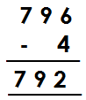 2+2=4 2+2=4

75 is not divisible by 7 hence 7962 is not divisible by 7 exactly.

**Activity**

State whether the following numbers are exactly divisible by 7

(a)105 (b) 133 (c) 686 (d) 8792

(e) 227955 (f) 18648 (g) 2864

(h) 18649 (i) 182

**DIVISIBILITY TEST FOR 8**

A number is divisible by 8 if the number formed by the last three digits is divisible by 8

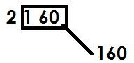1. State whether 2160 is divisible by8

160 is divisible by 8 hence 2160 is exactly divisible by8.

2. Find out whether 2080 is exactly divisible by 8

080 is divisible by 8 hence 2080 is divisible by 8 exactly.

3. Identify if 45094 is divisible by 8

094 is not divisible by 8 hence 45094 is not divisible by 8.

**Activity**

1. State whether the following numbers are divisible by 8

(a) 7960 (b) 18016 (c) 7320 (d) 65200 (e) 19098 (f) 8888

**DIVISIBILITY TEST FOR 9**

A number is divisible by 9 if the sum of its digits is divisible by 9.

1. State whether 198 is divisible by 9.

Sum=1+9+8

=18

18 is divisible by 9 hence 198 is divisible by 9 exactly.

2. Find whether 207 is divisible by 9.

Sum=2+0+7

=9

9 is divisible by 9 hence 207 is divisible by 9 exactly.

3. Find out if 21034 is exactly divisible by 9

Sum=2+1+0+3+4

=10

10 is not divisible by 9 hence 21034 is not divisible by 9 exactly.

**Activity.**

1. State whether the following numbers are exactly divisible by 9.

(a) 342 (b) 783 (c) 660

(d) 8757 (e) 4827 (f) 70308

(g) 54696 (h) 11034 (i) 10008

**DIVISIBILITY TEST FOR 10**

A number is divisible by 10 if it ends with 0.

1. State whether 120 is divisible by 10.

 **Solution**

120 ends with 0 hence divisible by 10

2. State whether 255 is divisible by 10.

 **Solution**

255 doesn’t end with 0 hence 255 isn’t divisible by 10 exactly.

**Activity**

State whether the following numbers are exactly divisible by 10.

(a)4050 (b)1980

(c)2020 (d)108

(e) 9110 (f) 1009

(h) 2345

**DIVISIBILITY TEST FOR 11**

A number is divisible by 11 if the difference between the sum of the digits in even places and the sum of the digits in the odd places is zero or divisible by 11.

Example

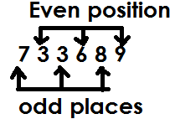Identify whether 733689 is exactly divisible by 11.

Sum of the digits in odd positions =7+3+8=18

Sum of the digits in even positions =3+6+9=18

Difference=18-18

=0

Therefore 733689 id divisible by 11.

**Example 2**

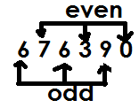Show whether 676390 exactly divisible by 11?

Sum of odd=6+6+9

=21

Sum of even=7+0+3

=10

Difference=21-10

=11

Since difference is divisible by 11 the number is divisible by 11.

**Activity**

Which of the following numbers is exactly divisible by 11?

(a) 2367 (b) 814 (c) 6425

(d) 7282 (e) 901938

**TYPES OF NUMBERS**

**1. Whole numbers**

It is where all other numbers are derived.

Whole numbers consist of 1 or more units and are not fractions

**Examples**

0, 1, 2, 3, 4, 5, 6, …

**2. Counting/ natural numbers**

These are numbers which show concrete quantity of something

**For example**

1, 2, 3, 4, 5, 6, …

**N.B** All whole numbers are counting numbers apart from zero (0)

**3.** **Even numbers**

These are numbers that are exactly divisible by 2

Even numbers have a pattern of +2 in ascending order and -2 in descending order.

**Examples.**

0, 2, 4, 6, 8, …

**N.B**

Even numbers end in an even digit.

Below is a set of the first 6 even numbers.

{0, 2, 4, 6, 8}

Find the sum of the first 4 even numbers

Solution

0,2,4,6

Sum = 0+2+4+6

= 12

**ODD NUMBERS**

These are numbers which when divided by 2, gives a remainder of 1. The first odd number is 1.

Below is a set the first 6 odd numbers.

{1, 3, 5, 7, 9}

All odd numbers end in an odd digit.

Odd numbers have a pattern of +2 in ascending order and -2 in descending order.

Find the product of the 4th and 6th odd numbers.

**Solution**

1, 3, 5, 74th, 9, 116th, 13

Product = 7x11

= 77

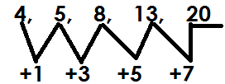Find the next number in the sequence

**PRIME NUMBERS**

A prime number is a number with only 2 factors; 1 and 2 itself.

Below is a set of prime numbers

{2,3,5,7,11,13,17,19,23………}

Find the sum of prime numbers between 6 and 15

**Solution**

7, 11, 13

Sum = 7+11+13

= 31

Find the sum of prime numbers between 20 and 30

23, 29

Sum = 23+29

= 52

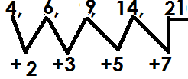Find the next number in the sequence

**COMPOSITE NUMBERS**

These are numbers with more than 2 factors.

The first composite number is 4. The rest include;

4, 6, 8, 9, 10, 12, 14, 15……

**TRIANGULAR NUMBERS**

These are numbers got by adding consecutive counting numbers.

The first triangular number is 1

1.

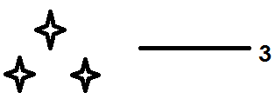

2.

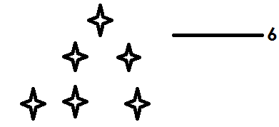

3.

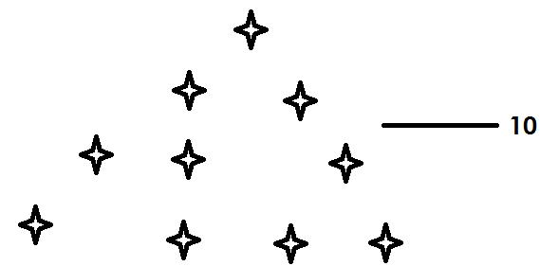

4.

**Finding triangular numbers**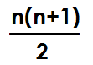

Formula=

**Examples**

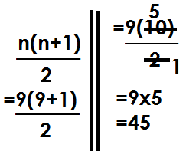1. Find the 9th triangular number

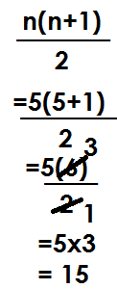2. Find the 5th triangular number

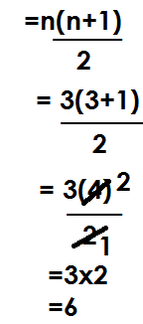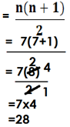3. Find the sum of the 7th and 3rd triangular number

7th 3rd=

Sum=28+6

=34

**Activity**

1. Find the 11th triangular number

2. Find the 17th triangular numbers

3. Find triangular numbers in these positions

(a) 8th (b) 21st

(c) 32nd (d) 4th

4. Find the sum of the 2oth and 15th triangular numbers.

5. What is the difference between the 10th and 6th triangular numbers?

6. Find the product of the 9th and 10th triangular numbers.

**CONSECUTIVE NUMBERS**

**Finding consecutive counting numbers**

**N.B**

Counting numbers have a pattern of +1 and -1 in ascending and descending orders respectively.

**Examples**

1. The sum of 3 consecutive counting numbers is 27. Find the numbers.

|  |  |  |  |
| --- | --- | --- | --- |
| 1st | 2nd | 3rd | sum |
| k | K+1 | K+2 | 27 |

Let the first number be k

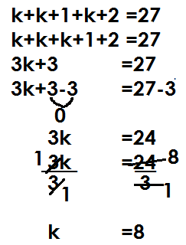 K + k + k + 1 + 2 = 27

3k + 3 = 27

3k + 3 – 3 = 27 – 3

3k = 24

=

K = 8

|  |  |  |
| --- | --- | --- |
| 1st | 2nd | 3rd |
| k | K+1 | K+2 |
| =8 | 8+1 | =8+2 |
|  | 9 | 10 |

(b) Find their range

Range = H - L

= 10 - 8

= 2

2. Find the sum of 3 consecutive counting numbers is 39. If the 2nd number is P. find the numbers.

|  |  |  |  |
| --- | --- | --- | --- |
| 1st | 2nd | 3rd | sum |
| P-1 | P | P+1 | 39 |

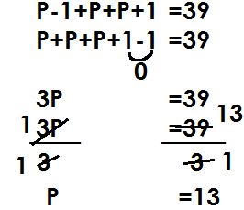

|  |  |  |
| --- | --- | --- |
| 1st | 2nd | 3rd |
| P-1 | P | P+1 |
| 13-1 | =13 | 13+1 |
| 12 |  | 14 |

(b) Find the range of numbers

Range=H-L

=14-12

=2

(c) Find the mean of the numbers

Mean = sum of items

 No.of items

=

=13

3. The sum of 3 consecutive counting numbers is 45 if the third number is k.

(a) Find the numbers

|  |  |  |  |
| --- | --- | --- | --- |
| 1st | 2nd | 3rd | sum |
| k-2 | k-1 | k | 45 |

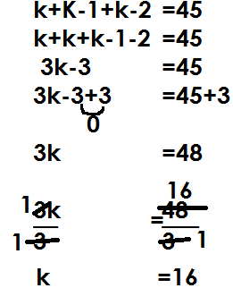

|  |  |  |
| --- | --- | --- |
| 1st | 2nd | 3rd |
| k-2 | k-1 | k |
| 16-2 | 16-1 | =16 |
| 14 | 15 |  |

(b) Find their range

Range=H-L

=16-14

=2

4. The average of 3 consecutive counting numbers is 8. Find the numbers

Let the first number be k

|  |  |  |  |
| --- | --- | --- | --- |
| 1st | 2nd | 3rd | average |
| K | K+1 | K +2 | 8 |

Sum of items = Average

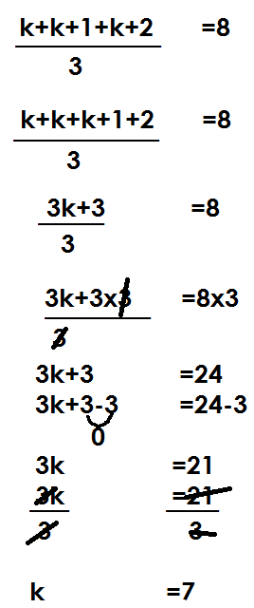No. of items

|  |  |  |
| --- | --- | --- |
| 1st | 2nd | 3rd |
| k | K+1 | K+2 |
| 7 | 7+1 | 7+2 |
| 14 | 8 | 9 |

**ACTIVITY**

1. The sum of 3 consecutive counting numbers is 42.

(a) Find the numbers

(b) Find the range of numbers

2. The sum of 3 consecutive counting numbers is 66. If the middle number is k,

(a) Find the numbers

(b) Find the range of the numbers

3. Given that the sum of consecutive counting numbers is 54. If the 4th number is P.

(a) Find the numbers

(b) Calculate the range of the numbers.

4. If the average of 3 consecutive counting numbers is 12.

(a) Find the numbers

(b) Find the range of numbers

5. The mean of 3 consecutive counting numbers is 15.

(a) Find the numbers

(b) Find the product of the numbers.

**FINDING CONSECUTIVE EVEN NUMBERS**

**N.B**

Even numbers have a pattern of +2 and -2 in ascending and descending orders respectively.

**Examples**

1. The sum of 3 consecutive even numbers is 42.

(a) Find the numbers

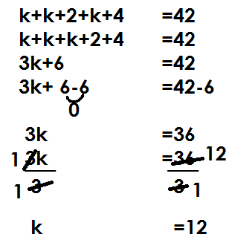 Let the 1st number be k

|  |  |  |
| --- | --- | --- |
| 1st | 2nd | 3rd |
| k | K+2 | K+4 |
| 12 | 12+2 | 12+4 |
|  | 14 | 16 |

(b) Find their range

Range = H-L

=16-12

=4

2. The sum of 4 consecutive even numbers is 44. If the last number is p.

(a) Find the numbers

|  |  |  |  |  |
| --- | --- | --- | --- | --- |
| 1st | 2nd | 3rd | 4th | Sum |
| p-6 | p-4 | p-2 | p | 44 |

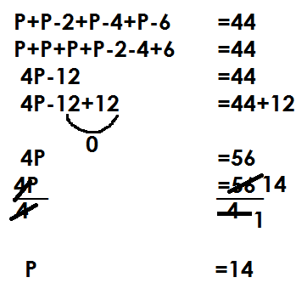

P+p-2+p-4+p-6 = 44

P+p+p+p-2-4-6 = 44

4p – 12 = 44

4p – 12 + 12 = 44 – 12

4p = 32

=

P = 8

|  |  |  |  |
| --- | --- | --- | --- |
| 1st | 2nd | 3rd | 4th |
| P-6 | P-4 | P-2 | P |
| 14-6 | 14-4 | 14-2 | =14 |
| 8 | 10 | 12 |  |

(b) Find their range

Range=H-L

=14-8

=6

3. The average of 3 consecutive even numbers is 8

(a) Find the numbers

|  |  |  |  |
| --- | --- | --- | --- |
| 1st | 2nd | 3rd | 4th |
| k | K+2 | K+4 | 8 |

Let the first number be k

Sum of items= average

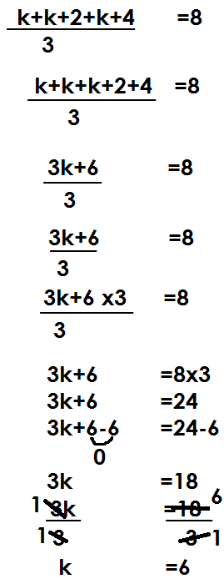No. of items

|  |  |  |
| --- | --- | --- |
| 1st | 2nd | 3rd |
| K | K+2 | K+4 |
| =6 | 6+2 | 6+4 |
|  | 8 | 10 |

**Activity**

1. The sum of 3 consecutive even numbers is 66.

(a) Find the numbers

(b) Find their range

2. The sum of 4 consecutive even numbers is 52.

(a) Find the numbers

(b) Find their range

3. The sum of 3 consecutive even numbers is 96. If the middle number is y.

(a) Find the numbers

(b) Find their range

4. Four consecutive even numbers add up to 28. If the 4th number is k

(a) Find the numbers

(b) Find their range

5. The average of 3 consecutive even numbers is 22

(a) Find the numbers

(b) Find the product of the numbers

**PRIME FACTORIZATION**

Prime factorization is a way of dividing numbers using its prime factors

Prime factors of numbers are written in two ways;

* Subscript form/ Set notation form
* Power form/ Multiplication form

**Example 1**

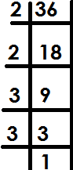Prime factorize 36 giving your answer in subscript form



**Example 2**

Prime factorize 50 and give your answer in power form

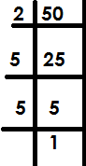**Solution**

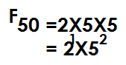

**Example 3**

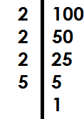Express 100 as a product of its prime factors.



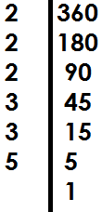Prime factorize 360 in power form

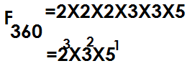

**Activity**

1. Prime factories the following and give your answer in subscript form

(a) 18 (b) 72 (c) 144

2. Prime factorize the following and give your answer in power form.

(a) 120 (b) 150 (c) 240

(d) Express each number as a product of its prime factors.

(a) 64 (b) 210 (c) 60

**Finding umbers that were prime factorized**

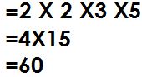1. Given that FQ = {21, 22,31, 51} Find Q

Q

2. If k = 23x51. Find k

K= (2x2) x (2x5)

= 4x10

= 40

3. Find the prime factorized number in the following

Fy = {21, 31, 32, 51}

Y = 21x31x32x51

= (2x3) x (3x5)

= 6x15

= 90

4. FK = 24x31

= (2x2) x (2x2) x3

= 4x4x3

= 16x3

=48

**Activity**

1. What number was prime factorized to give?



2. Given k = 24 x 51. Find the value of k.

3. Find the value of Z if, FZ = 21 x 32 x51

4. Find the prime factorized numbers in the following

FM = {21, 22, 23, 32, 51}

K = 2x2x3x3x5

M = 32x52

 **Finding missing factors**

1. If . Find y.

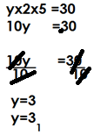 **Solution**

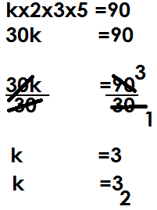2. Given that 21, 31, k and 51 are prime factors of 90. Find the value of k.

3. If 12= (21, m, 31). Find m

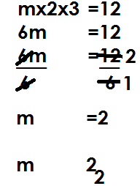

**Activity**

1. If 21, 31, 51 and y are prime factors of 150. Find y

2. Given that {21 ,22, 23, n, 51} are prime factors of 120. Find the value of n

3. If {21, 22, k, 32, 51} are prime factors of 180. Find the value of k.

4. Given that 36= {21, 22, 31, x}. Find the value of x.

5. If 100 = {21, p, 51, 52}. Find the value of p.

6. The prime factors of 360 are 21, 22, 23, m, 32 and 51. Find the value of m.

**Representing prime factors on a Venn diagram**

1. Prime factorize 12 and 18 and represent the prime factors on a Venn diagram.

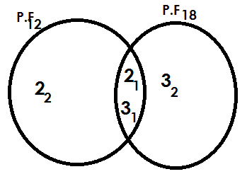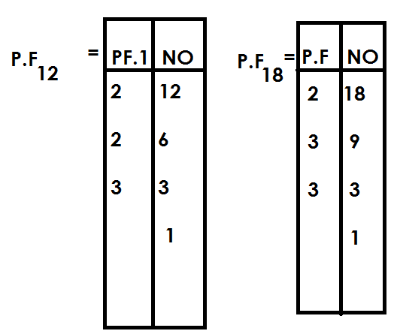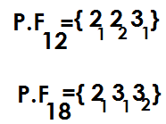

(b) Find the G.C.F of 12 and 18

GCF = intersection product

= 2x3

= 6

(c) Find LCM of 12 and 18

LCM = union product

= (2X2) X (3X3)

= 4X9

= 36

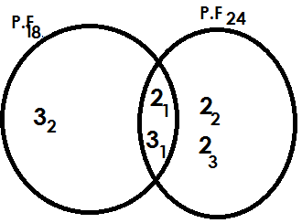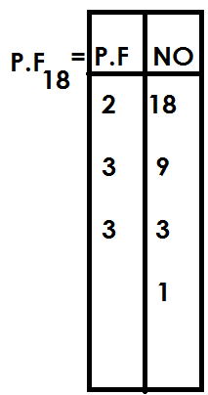2. Prime factorize 18 and 24 and represent the prime factors on a Venn diagram.

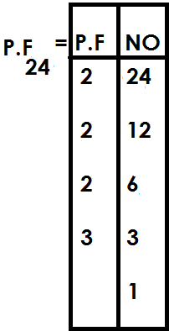



(b) Use the Venn diagram to find;

(i) GCF of 18 and 24

GCF=2X3

=6

(ii) LCM of 18 and 24

LCM=union product

= (3x2) x (3x2) x2

= (6x6) x2

=36x2

=72

**Activity**

1. Prime factorize 24 and 36 and represent the prime factors on a Venn diagram.

(b) Use the Venn diagram to find

(i) GCF of 24 and 36.

2. Show the prime factors of 36 and 48 on a Venn diagram.

(b) Use the Venn diagram to find.

(i) G.C.F of 36 and 48

(ii) L.C.M of 36 and 48

3. Prime factorize 45 and 60 and represent the prime factors on a Venn diagram.

(b) Use the Venn diagram to find;

(i) GCF of 45 and 60

(ii) LCM of 45 and 60

4. Show the prime factors of 30 and 36 on a Venn diagram

(b) Using the Venn diagram; find

(i) HCF of 30 and 36

(ii) LCM of 30 and 36

5. Show the prime factors of 120 and 180 on a Venn diagram

(b) Use the Venn diagram to find,

(i) GCF of 120 and 180

(ii) LCM of 120 and 180

**Finding unknown values on a Venn diagram**

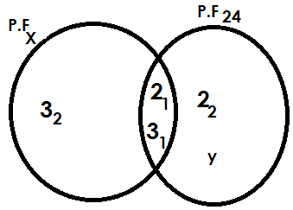1. Use the Venn diagram below to answer questions that follow.

(a) Find the value of

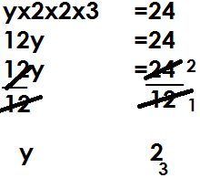(i) y

(ii) x

X = (3x2) x3

X = 6x3

X = 18

(b) Find GCF of x and 24

GCF=2x3

=6

(c) Find LCM of x and 24

LCM= (3x2) x (3x2) x y

= (3x2) x (3x2) x2

= (6x6) x2

=36x2

72

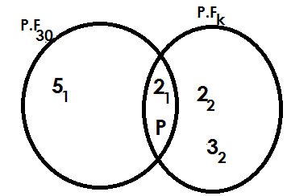2. Use the Venn diagram below to answer questions that follow.

(a) Find the value of

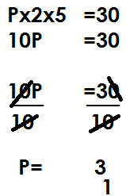(i) P

(ii) K

K = 2XPX2X3

K = (2X3) X (2X3)

K = 6X6

K = 36

(b) Find HCF of 30 and k

HCF = 2xp

= 2x3

= 6

(c) Find the LCM of 30 and k

LCM = 5x2xpx2x3

= (5x2) x (3x2x3)

= 10x18

= 180

**Activity**

1. Use the Venn diagram below to answer questions that follow.

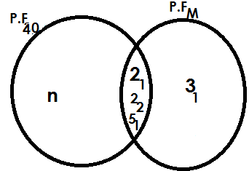

a) Find the value of;

(i) n (ii) m

(b) Find the GCF of 40 and m

(c) Find the LCM of 40 and m

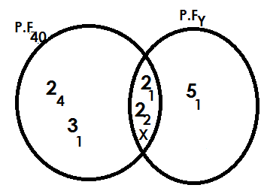2. Below is a Venn diagram. Use it to answer questions that follow.

(a) Find the value of

(i) X (ii) Y

(b) Find the GCF of 48 and y.

(c) Find the LCM of 48 and y.

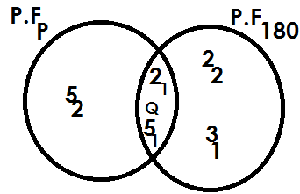3. Use the Venn diagram below to answer questions that follow.

(b) Find the value of

(i) Q

(ii) P

(c) Find the GCF of p and 180

(d) Find the LCM of p and 180.

**Finding lowest common multiple**

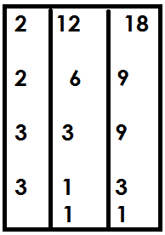1. Find the LCM of 12 and 18

LCM= (2x2) x (3x3)

=4x9

=36

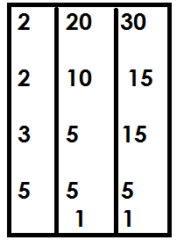2. Find the LCM of 20 and 30

LCM= (2x2) x (3x5)

=4x15

=60

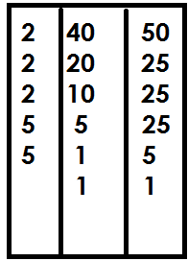3. Find the LCM of 40 and 50

LCM= (2x2x2) x (5x5)

=8x25

=200

**Activity**

1. Find the LCM of the following numbers

(a) 18 and 21 (b) 18 and 24

(c) 16 and 20 (d) 45 and 50

(e) 20, 30 and 40 (f) 18,20 and 30

(g) 9, 12 and 15 (h) 32, 24 and 24

**APPLICATION OF LCM**

1. Find the smallest number when divided by 30 or 24 there is no remainder.

**Solution**

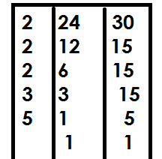 Smallest no. =LCM

= (2x2x2) x3(3x5)

=8x15

=120

2. Find the least number of books which when divided by either 20 or 36,3 books remain.

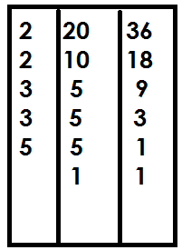 Least No.=LCM + remainder

= (2x2x3) x (3x5)

=12x15

=180

=180+3 =183 books

3. Two bells ring at interval of 20 minutes and 50 minutes for lower and upper section respectively.

(a) After how long will the bells ring together?

Common minutes=LCM

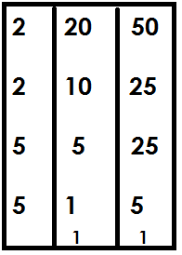

= (2x2) x(5x5) minutes

=4x 25 minutes

=100 minutes

The two bells will ring together after 100 minutes.

(b) If they last rung at 8:00am, when will they ring together again?

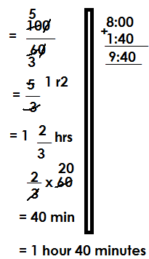 60 minutes=1hr

100minutes

They will ring together again at 9:40 am

4. Two soldiers were shooting at a target at an interval of 1 hour and 1 hours respectively.

(a) After how long will they shoot together?

Solution

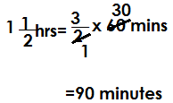 1 hour=60 minutes 1hr=60 mins

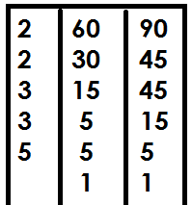 Common minutes = LCM

= (2x2) x (3x3) x5

= 4x9x5

= 180 minutes

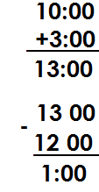(b) If they last shoot together at 10:00am, when did they shoot together again?

 60minutes=1hr

180 min=

=3 hours

They shoot together again at 1pm.

**Activity**

1. Find the smallest number that when divided by 12 or 9 there is no remainder.

2. What is the least number of sweet that when shared by either 8 or 20 pupils, no sweet remains?

3. Find the smallest number of books that when divided by either 18 or 24, 7 books remain.

4. What is the lowest number that when divided by either 11 or 13, 5 becomes the remainder?

5. At ABC P/S two bells ring at an interval of 30 and 40 minutes for nursery and primary respectively.

(a) After how long will the two bells will they ring together again

(b) If they first rung at 8:30 am, when will they ring together again?

6. Three bells for lower, middle and upper section at Kibuku P/S ring at an interval of 40 minutes, 50 minutes and 1 hour respectively.

(a) After how long will they be sounded together again?

(b) If they are first sounded at 8:00am, when are they sounded together again for the second time?

7. At a bus station three buses leave at an interval of 50 minutes, 1 hour and 1 hours respectively.

(a) After how long will the three buses leave at the same time?

(b) If they last left together at 10:00am, at what time will they leave together again?

**FINDING GCF/HCF**

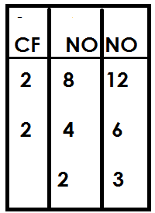1. Find the GCF of 8 and 12

= 2X2

= 4

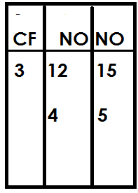2. Find the HCF of 12 and 15

HCF=3

3. Find the largest number that divides 6 and 8 without any remainder.

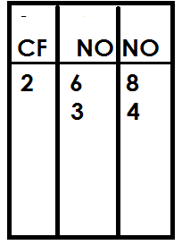 Largest no= HCF

HCF=2

4. Find the largest number that divides 18 and 24

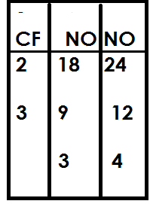 Largest no. =HCF

= 2x3

= 6

**Activity**

1. Find the GCF of the following numbers

(a) 15 and 20

(b) 24 and 36

(c) 18 and 21

(d) 9 and 21

(e) 11 and 22

2. Find the largest number that divides 9 and 24 without any remainder.

3. What is the highest number that divides 24 and 30 without a remainder?

4. Find the highest number of boys that you can give 21 and 24 pens equally?

**APPLICATION OF LCM AND GCF.**

1. The LCM of two numbers is 18. Find the second number.

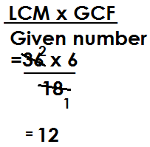 **Solution**

2nd no. =

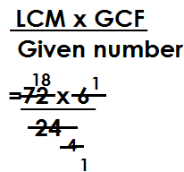2. The LCM of two numbers is 72 and their GCF is 6. If one of the numbers is 24, find the second number

2nd no. =

2nd no. = 18

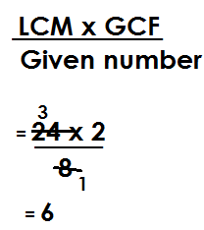3. The LCM of two numbers is 24 and their GCF is 2. If one of the numbers is 8. Find the second number

2nd no.=

**Activity**

1. The LCM of two numbers is 72 and their GCF is 6. If the first number is 18, find the second number.

2. The LCM of two numbers is 120 and their HCF is 10. If the first numbers is 40. Find the second numbers.

3. The LCM of two numbers is 225 and their GCF is 5. Find the second number if the first number is 25.

4. The LCM of two numbers is 300 and their GCF is 10. Given that the first number is 50, find the second number.

5. The LCM of two numbers is 144 and their GCF is 12. Find the second number if the first number is 36.

6. The product of two numbers is 216 and their cm is 36. Find their GCF.

7. The product of two numbers is 432 and their LCM id 72. Find their GCF.

**SQUARE AND SQUARE ROOT**

**Square numbers.**

A square number is a product of two same numbers.

A square is a number obtained by multiplying a given number by itself.

**Examples of square numbers**

12 = 1x1

= 1

22 = 2x2

= 4

32 = 3x3

= 9

42 = 4x4

= 16

52 = 5x5

= 25

{1, 4,9,16,25, 36, 49, 64, …}

**SEQUENCE OF SQUARE NUMBERS**

1. Find the next number in the sequence of

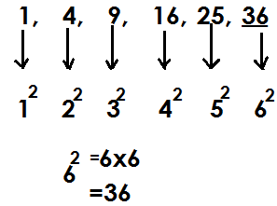 1,4,9,16,25,36

2. Find the next two numbers in the series of

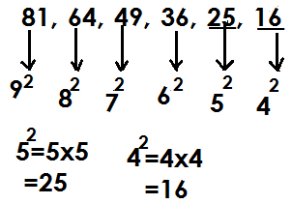 81, 64, 49, 36, 25, 16

**Activity**

Find the next numbers in the following series

(a) 1, 4, 9, 16, ________

(b) 36, 49, 64, 81, _____

(c) 100, 81, 64, 49, _____, _____

(d) 100, 121, 144, 169, ____, _____

(e) 81, 64, 49, 36, _____, ________

(f) 25, 16, 9, 4, _____

(g) 400, 361, 324, 289, ____, ____

1. Find the square of 9

92 = 9x9

= 81

2. What is the square of 13?

132 = 13x13

= 169

3. Find the square of 100

1002 = 100x100

= 10000

**Activity**

1. Find the square of the following whole numbers.

(a) 4 (b) 11

(c) 17 (d) 20

(e) 12 (f) 19

(g) 8 (h) 18

(i)144 (j) 132

(k) 225 (l) 500

**FINDING SQUARE OF FRACTIONS**

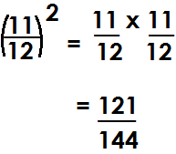a). Find the square of

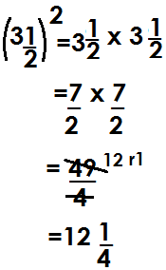(b) Find the square of 3

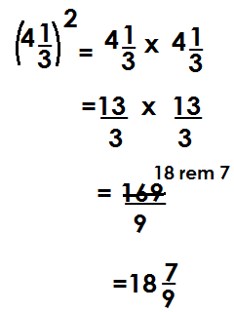(c) Find the square of 4

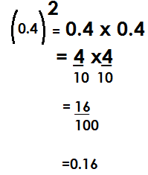(d) Find the square of 0.4

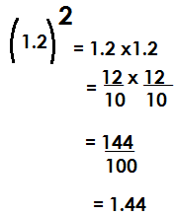(e) Find the square of 1.2

**Activity**

(a) (b) (c) (d) (e) (f) 1 (g) 2

(h) 5 (i) 3 (j) 0.8 (k) 0.06 (l)1.4 (m) 1.44 (n) 25.5

**SQUARE ROOTS**

A square root is a number that was multiplied by itself to obtain a square number.

The square root sign is

**Finding the square root of whole numbers**

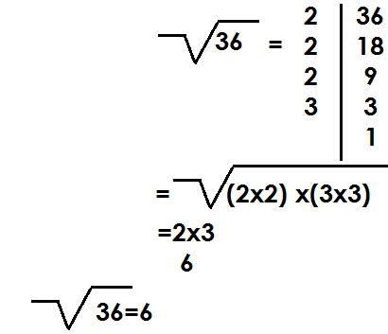1. Find the square root of 36.

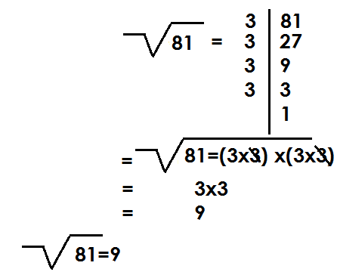2. Find the square root of 81

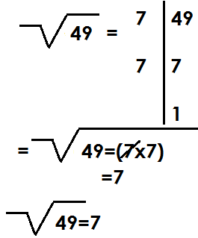3. What is the square root of 49?

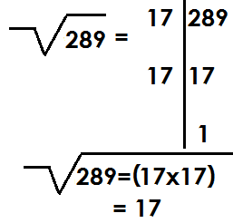4. Find the square root of 289

**Activity**

1. Find the square root of the following

(a)4 (b) 9 (c) 16 (d) 25 (e) 64

(f) 100 (g) 121 (h) 144 (i)169 (j) 196

(k) 225 (l) 256 (m) 324 (n) 400

**FINDING SQUARE ROOT OF FRACTIONS.**

**NOTE:**

While finding square root of fractions, the answers should take the nature of the question.

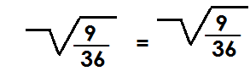1. Find the square root of

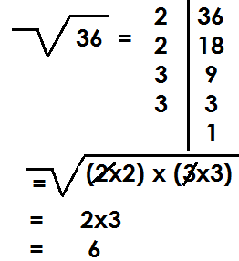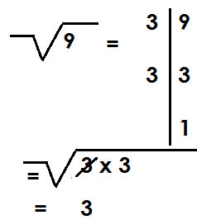

= =

=

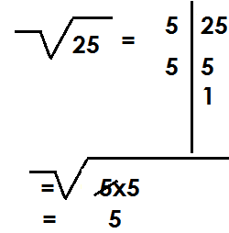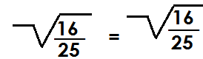2. Find the square root of

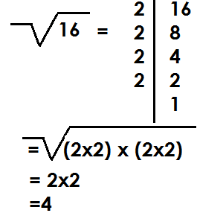 = =

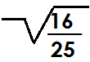

Therefore =

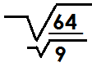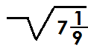3. Find the square root of 7

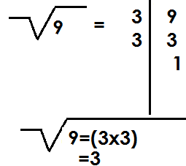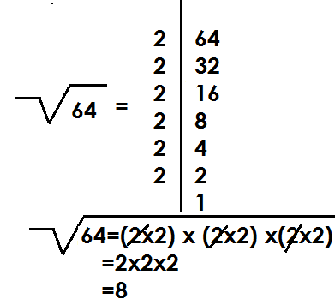 =

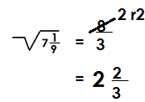

4. Find the square root of 1

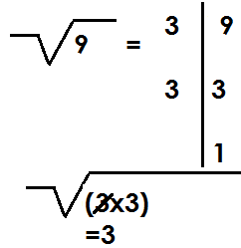 1 =

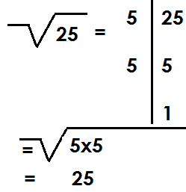

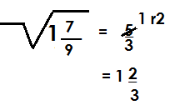

**Activity**

Find the square root of the following

(a) (b) (c) (d) (e) (g) 2

(h) 6 (i) 7 (j) 20 (k) 11 (l) 1

**FINDING SQUARE ROOT OF DECIMALS**

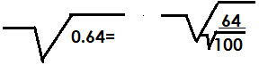1. Find the square root of 0.64

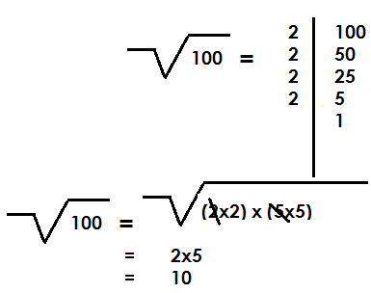

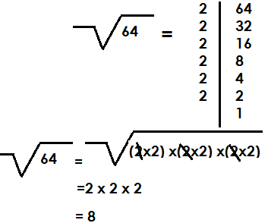

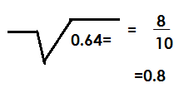

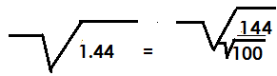2. Find the square root of 1.44

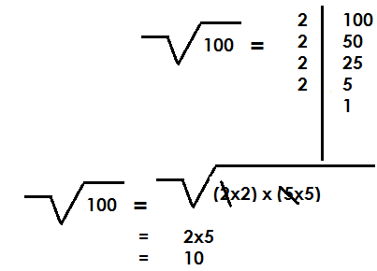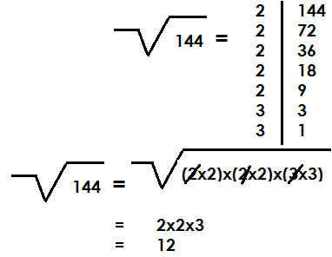

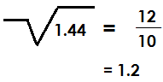

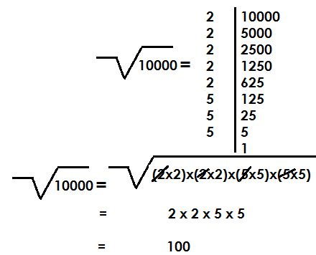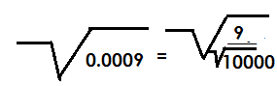3. Find the square root of 0.0009



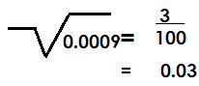

**ACTIVITY**

Find the square root of the following

(a) 0.09 (b) 0.81

(c) 2.56 (d) 4.41

(d) 0.36 (f) 1.96

(g) 0.0064

**APPLICATION OF SQUARE ROOTS**

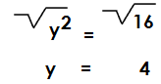1. Solve: y2=16

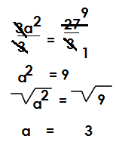2. Solve: 3a2=27

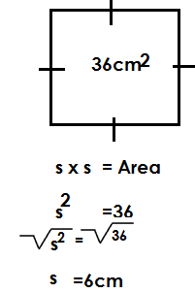3. The area of a square is 36cm2. Find the length of each side

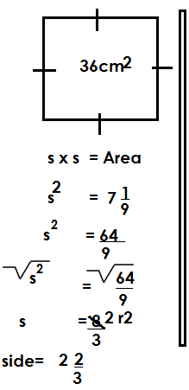4. The area of a square garden 7 . Find the length of its side.

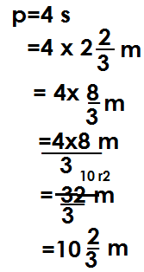 Find its perimeter

**Activity**

1. The area of a square is 49cm2. Find its side.

2. A square garden has area of 81cm2. Find the length of its side.

3. Find the length of one side of a square of area 1 m2

4. Find the perimeter of a square garden whose area is 64m.

5. Find the perimeter of a square garden when are is 1.96m2

6. Solve: x2=25

7. Solve for k= K2=144

8. Solve: p x p =18

9. Solve: 2y2=72

10. Solve for k: 5kxk=500.

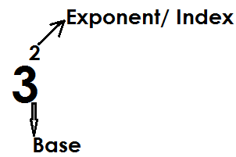**INDICES**

Given

To simplify in indices; leave the answer in power form.

To workout is to evaluate and give the value of the expression.

**ADDITION AND SUBTRACTION BY EXPANSION**

**Note:**

Expand the base by multiplying it as many times as the exponent.

Any number raised to exponent 0, gives one (1) and any number raised to exponent one (1) gives that same number.

1. Workout: 23+42

= (2x2x2) + 4x4

=8 +16

=24

2. Workout: 103+52

**Solution**

= (10x10x10) + (5x5)

=1000+25

=1025

3. Workout: 43-32

= (4x4x4)- (3x3)

= 64-9

= 55

4. Workout: 32-23

= (3x3)- (2x2x2)

= 9-8

= 1

5. Workout: 23+90+21

(2x2x2) + 1+2

8+3

11

6. Workout: 142-120

= (14x14) -1

= 196-1

= 195

**Activity**

Workout the following

(a) 43+23 (b) 23+32+50

(c) 42+32 (d) 34+42+21

(e) 34+40 (f) 42-32

(g) 62-23 (h) 43-51

(i) 100-33

**LAW OF INDICES IN MULTIPLICATION**

**Note:**

When multiplying powers of the same base, maintain one common base and add the exponents.

**Examples**

1. Simplify: 22 x 23

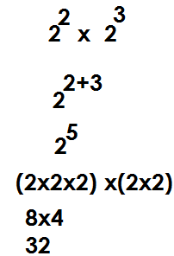 **Solution**

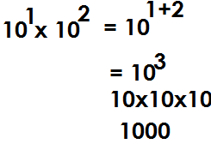2. Workout: 101x102

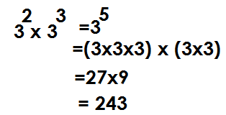3. Simplify: 32x33

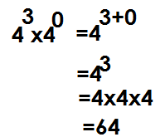4. Simplify: 43 x40

**Activity**

(a)24x22 (b) 53x51

(c) 31x33 (d) 23x2x21

(e) 104 x10 (f) 53x52

(g)32x31x30 (h) 92x90

**Laws of indices in division**

**Note:**

When dividing powers of the same base, maintain one common base and then subtract the exponents.

**Examples**

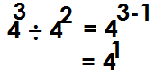1. Simplify: 43 42

2. Workout: 65 ÷ 64

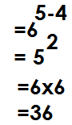 65 ÷ 64

3. Workout: 34 ÷ 3

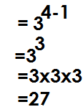34 ÷ 31=

4. Workout: 53 ÷ 50

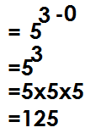53 ÷ 50 =

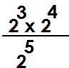

5.

Workout:

 **Solution**

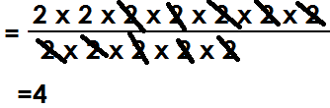

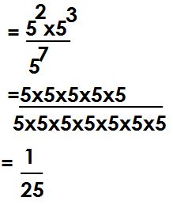6. Workout:

7. Workout:

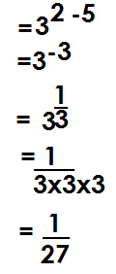

8. Work out the following

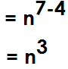(a) n7 ÷ n4

(b) p**3a** ÷ p**a**

P**3a**-p**a**

=p**2a**

**Activity**

1. Workout the following

(a)75 ÷ 74

(b) 103 ÷ 102

(c) 512 ÷ 59

(d) 37 ÷34

(e) 43 ÷ 41

(f)52 ÷ 50

2. Simplify the following.

(g) n10 ÷ n3

(h) 132k ÷ 13k